


本科毕业设计说明书（论文）
Undergraduate International Students’ Graduation Project Report (Thesis)

基于 Web 的花卉智能识别与科普系统的设计与实现
DESIGN AND IMPLEMENTATION OF A WEB-BASED INTELLIGENT FLOWER RECOGNITION AND POPULAR SCIENCE SYSTEM

学 院： 计算机科学与技术学院、软件学院
专 业： 软件工程（中外合作办学）
班 级： 2022软件工程（中外合作办学）02
学 号： 202203340230
学生姓名： 周全
指导老师： 穆攀
提交日期： 2026年6月

摘 要
随着人工智能、计算机视觉和 Web 技术的发展，图像识别应用逐渐进入日常生活与科普教育场景。针对普通用户在识别陌生花卉和获取相关植物知识时存在的不便，本文设计并实现了一个基于 Web 的花卉智能识别与科普系统。系统旨在通过花卉图像识别模型和结构化花卉知识库，为用户提供图片识别、结果展示、知识浏览和科普问答等服务。
在花卉识别模型方面，本文采用 Oxford 102 Flowers 数据集作为实验数据来源，选取 MobileNetV2、ResNet18 和 EfficientNet-B0 三种经典卷积神经网络进行对比实验。针对数据集训练样本相对有限的问题，本文采用迁移学习和两阶段微调策略进行模型训练。第一阶段冻结预训练模型的特征提取层，仅训练新替换的分类头；第二阶段解冻全部网络层，并使用较小学习率进行整体微调。实验结果表明，EfficientNet-B0 在三种模型中取得了最优表现，其验证集准确率达到 89.80%，测试集准确率达到 87.45%。因此，本文最终选择 EfficientNet-B0 作为系统部署模型，并在推理阶段返回 Top-3 预测结果及对应置信度，提高识别结果的参考价值。
在系统实现方面，本文采用前后端分离架构。前端基于 Vue.js 和 Vite 实现用户交互界面，后端基于 FastAPI 构建接口服务，模型推理部分使用 PyTorch 实现，数据库采用 SQLite 保存用户信息、识别历史、收藏记录和问答会话等数据。系统实现了用户注册登录、花卉图片上传识别、识别结果展示、花卉科普信息浏览、历史记录、收藏管理和轻量级科普问答等功能。其中，问答模块基于本地结构化 JSON 花卉知识库实现轻量级检索增强问答，并在外部模型接口不可用时提供本地兜底回答。系统已部署至云服务器环境，用户可通过浏览器访问系统并完成花卉识别、科普信息浏览和轻量级问答操作。综合来说，本文系统能够完成从花卉图片上传、模型识别到科普信息展示的完整流程，具有一定的实用价值和扩展意义。
关键词： 花卉识别，卷积神经网络，迁移学习，EfficientNet-B0，Web 系统，科普问答

ABSTRACT
With the development of artificial intelligence, computer vision and Web technology, image recognition applications have gradually entered the scene of daily life and popular science education. Aiming at the inconvenience of ordinary users in identifying unfamiliar flowers and obtaining relevant plant knowledge, this paper designs and implements a web-based flower intelligent recognition and science popularization system. The system aims to provide users with services such as image recognition, result display, knowledge browsing and popular science question answering through flower image recognition model and structured flower knowledge base.
In terms of model, this paper uses Oxford 102 Flowers dataset for experiments, selects MobileNetV2, ResNet18 and EfficientNet-B0 three convolutional neural networks for comparison, and completes model training based on transfer learning and two-stage fine-tuning strategy. The experimental results show that EfficientNet-B0 performs best, the accuracy of the verification set reaches 89.80%, and the accuracy of the test set reaches 87.45%. Therefore, this paper finally uses it as a system deployment model, and returns Top-3 prediction results and confidence in the inference stage.
In terms of system implementation, this paper adopts the front-end and back-end separation architecture. The front-end is based on Vue.js and Vite, the back-end is based on FastAPI, the model inference part uses PyTorch, and the database uses SQLite. The system realizes the functions of user login registration, flower image upload recognition, popular science information display, historical record, collection management and lightweight popular science question and answer. The system has been deployed on a cloud server, allowing users to access the main functions through a browser. The results show that the system in this paper can complete the complete process from flower picture upload, model recognition to popular science information display, which has certain practical value and extended significance.

Keywords: Flower Recognition, Convolutional Neural Network (CNN), Transfer Learning, EfficientNet-B0, Web System, Popular Science Question Answering

CONTENT
摘 要 I
ABSTRACT II
CHAPTER 1: INTRODUCTION 1
1.1 Background 1
1.2 The Purpose and Significance of Project 2
1.3 About system 3
1.4 The Organization of This Article 4
1.5 Chapter Summary 5
CHAPTER 2: RELATED WORK 6
2.1 Methods on Flower Image Recognition 6
2.1.1 Traditional Image Recognition Methods 6
2.1.2 Deep Learning Methods for Flower Recognition 7
2.1.3 Research Status and Development Trend Analysis 8
2.2 Related Techniques on Project 9
2.2.1 FastAPI 10
2.2.2 Vue.js and Vite 10
2.2.3 Deep Learning Framework: PyTorch 10
2.2.4 Transfer Learning 11
2.2.5 Convolutional Neural Network and Classic Classification Networks 11
2.2.6 SQLite and SQLAlchemy 12
2.2.7 Lightweight Retrieval-Augmented Question Answering 12
2.3 Chapter Summary 13
CHAPTER 3: PROPOSED METHOD FOR FLOWER RECOGNITION 14
3.1 Overall Idea 14
3.2 Data Processing 15
3.2.1 Dataset Introduction 15
3.2.2 Dataset Split 16
3.2.3 Image Preprocessing 17
3.2.4 Data Augmentation 17
3.2.5 Data Normalization 18
3.3 Architecture of Flower Recognition Model 19
3.3.1 Problem Formulation 19
3.3.2 Pre-trained CNN Backbone 20
3.3.3 Feature Extraction 22
3.3.4 Classification Head 23
3.3.5 Two-stage Fine-tuning Strategy 24
3.3.6 Top-3 Prediction 25
3.4 Experiments and Analysis 25
3.4.1 Experimental Environment 26
3.4.2 Evaluation Criteria 27
3.4.3 Ablation Study 28
3.4.4 Comparison with Different Models 29
3.4.5 Training Curve Analysis 30
3.4.6 Confusion Matrix and Confused Class Pairs Analysis 33
3.4.7 Analysis of Flower Recognition Model 35
3.5 Chapter Summary 36
CHAPTER 4: SYSTEM DESIGN AND DEVELOPMENT 38
4.1 Requirement Analysis 38
4.1.1 Functional requirements 38
4.1.2 Non-functional requirements 39
4.2 System Context 40
4.2.1 Users 41
4.2.2 External Systems 41
4.2.3 System Feature 42
4.3 System Interface 46
4.3.1 Interface Generalization 46
4.3.2 Registration and Login Interface 47
4.3.3 Flower Recognition and Result Interface 48
4.3.4 Flower Knowledge Base Interface 49
4.3.5 History and Favorite Interface 50
4.3.6 Question Answering Interface 51
4.4 Chapter Summary 52
CHAPTER 5: CONCLUSION AND FUTURE WORK 53
5.1 Conclusion 53
5.2 Future Work 54
Reference 56
Acknowledgment 59

CHAPTER 1: INTRODUCTION

1.1 Background
With the rapid development of artificial intelligence, computer vision and Internet technology, image recognition technology has been widely used in intelligent security, medical imaging, agricultural production, ecological protection and daily life services. As a basic task in computer vision, image classification aims to enable the computer to judge the category of the target according to the image content. Early image recognition methods mainly rely on artificially designed features, such as color, texture, edge and shape. However, these methods are sensitive to illumination changes, shooting angles, complex backgrounds, and target morphological differences, and their generalization ability is limited. Since the breakthrough performance of convolutional neural networks in large-scale image classification tasks [1], deep learning has significantly changed the research methods in the field of image recognition. Compared with traditional hand-crafted features, convolutional neural networks can automatically learn multi-level features from original images, which makes them more suitable for complex visual recognition tasks.
Flowers are common plant types in the natural environment and urban landscape, with high ornamental, ecological and popular science value. In scenes such as campuses, parks, botanical gardens and home gardening, ordinary users often encounter unfamiliar flowers, but it is difficult for them to accurately determine the type of flowers by the naked eye alone, and it is difficult to quickly understand their morphological characteristics, growth habits and conservation methods. Compared with ordinary object classification, flower recognition has certain fine-grained characteristics. Different flower categories may be very similar in color, petal shape and overall structure, while images in the same category may be very different due to different growth stages, lighting conditions and shooting angles. The Oxford 102 flower dataset contains 102 flower categories, covering changes in scale, posture, and illumination [2], which is very suitable for verifying the performance of the flower recognition model. Therefore, it is of practical significance to construct an accurate and convenient intelligent flower recognition system.
In recent years, convolutional neural network models such as ResNet, MobileNetV2 and EfficientNet have further promoted the development of image classification technology. ResNet alleviates the difficulty of deep network training through residual connection [3]; mobileNetV2 uses an inverted residual structure and a linear bottleneck design, which reduces the amount of model calculation while maintaining good recognition performance [4]; efficientNet balances the network depth, width and input resolution through a composite scaling method, and achieves good results between accuracy and parameter efficiency [5]. These models provide an effective technical basis for flower image recognition.
At the same time, the development of network technology enables intelligent recognition models to serve ordinary users in a more convenient way. Compared with independent local programs, web-based systems have the advantages of cross-platform access, easy maintenance, and convenient functional expansion. Users only need to upload flower pictures through the browser to obtain recognition results and related popular science information. In addition, retrieval enhancement generation also provides a new idea for knowledge-based question answering system. Its core idea is to combine the external knowledge retrieval results with the generation model to improve the application of external knowledge in knowledge-intensive tasks [6]. Therefore, this paper combines the flower recognition model based on deep learning, web application system and structured flower knowledge base to design a web-based flower intelligent recognition and popular science system, which can provide users with more intuitive and convenient flower recognition and knowledge services.

1.2 The Purpose and Significance of Project
The purpose of this project is to design and implement a Web-based intelligent flower recognition and popular science system. The system aims to provide ordinary users with an accessible tool for flower identification and knowledge acquisition. Users can upload flower images through a browser and obtain the predicted flower category, Top-3 candidate results, confidence scores and related popular science information. Since image-based plant recognition has important application value in plant classification, ecological education and public science popularization [7], this project attempts to transform a flower recognition model into a practical Web application.
At the algorithm level, this project focuses on building a flower image classification model suitable for the Oxford 102 Flowers dataset. Considering that deep learning methods have shown strong performance in plant identification and plant species recognition [8][9], and recent PlantCLEF tasks also reflect the development of plant recognition toward large-scale and complex-scene applications [10][11], this paper selects MobileNetV2, ResNet18 and EfficientNet-B0 for comparative experiments. To reduce the influence of limited training samples, transfer learning is adopted to make use of knowledge learned from large-scale source datasets [12]. Meanwhile, the use of ImageNet pre-trained models provides a practical basis for improving training efficiency and recognition performance [13].
At the system level, this project aims to integrate the trained recognition model into a complete Web-based application. The system adopts a front-end and back-end separation architecture, using Vue.js for user interaction, FastAPI for back-end services, PyTorch for model inference and SQLite for data storage. In addition to flower image recognition, the system also implements user login, recognition history, favorite management, flower knowledge display and lightweight question answering. These functions make the system more than a simple classification program, but a small-scale flower popular science platform.
Another goal of this project is to improve the usefulness of recognition results. Simply returning a flower name is not enough for users who want to understand flower characteristics, growth habits and maintenance knowledge. Therefore, this project constructs a structured JSON flower knowledge base and introduces a lightweight retrieval-augmented question answering mechanism. Existing open-domain question answering studies show that combining retrieval with question answering models can improve the use of external knowledge [14][15]. Based on this idea, the system retrieves relevant flower knowledge according to the recognition result and provides users with more informative popular science answers.
In summary, the significance of this project lies in three aspects. First, it verifies the effectiveness of transfer learning-based convolutional neural networks on flower image classification. Second, it implements a usable Web system that connects model training results with real user interaction. Third, it combines flower recognition with structured knowledge display and lightweight question answering, which improves the practical value and educational significance of the system.

1.3 About system
This system is a Web-based flower intelligent recognition and popular science platform, mainly for ordinary users of flower recognition and knowledge acquisition needs. The system adopts the front-end and back-end separation architecture, combined with EfficientNet-B0 recognition model, FastAPI back-end, Vue front-end and SQLite database, to realize the functions of image upload recognition, result display, popular science information browsing, historical collection and lightweight question answering. The main development environment and technical configuration of the system are as follows.
Back-end Language: Python
Back-end Framework: FastAPI
Front-end Framework: Vue.js
Deep learning Framework: PyTorch
Database: SQLite
IDE: Pycharm
GPU: GeForce RTX 3050 Laptop GPU

1.4 The Organization of This Article
Chapter 1: Primarily introduces the background and significance of the project. It then presents the basic information of the flower intelligent recognition and popular science system, including the development environment, system framework and main technologies used in this project.
Chapter 2: This chapter mainly introduces the related work and technologies of this project. It first summarizes the research status of flower image recognition and plant image classification, and then introduces the key techniques used in the system, including FastAPI, Vue.js, PyTorch, transfer learning, convolutional neural networks, SQLite and lightweight retrieval-augmented question answering.
Chapter 3: This chapter is the core part of the recognition method. It mainly introduces the overall idea of flower image recognition, data processing, model architecture, transfer learning strategy and Top-K prediction. In addition, several experiments are conducted to compare MobileNetV2, ResNet18 and EfficientNet-B0, and the final deployed model is selected according to the experimental results.
Chapter 4: This chapter mainly describes the design and development of the Web-based flower recognition and popular science system. It analyzes the functional and non-functional requirements of the system, introduces the users, external systems and main system features, and presents the implementation and interface design of modules such as user login, flower recognition, knowledge display, history records, favorites and lightweight question answering.
Chapter 5: This chapter summarizes the work completed in this paper and discusses the future work. It reviews the model training, system development and main functions implemented in this project, and points out possible improvement directions, including improving recognition accuracy, expanding the flower dataset, enriching the knowledge base and optimizing system deployment.

1.5 Chapter Summary
This chapter mainly introduces the research background, the purpose and significance of the project, the basic situation of the system and the organization structure of the paper of the flower intelligent recognition popular science system based on Web. Through the content of this chapter, the research objectives, system development direction and overall chapter arrangement of this paper can be clarified, which lays a foundation for subsequent related technology introduction, flower recognition method design and system implementation.

CHAPTER 2: RELATED WORK

2.1 Methods on Flower Image Recognition
Flower image recognition is an important branch of plant image recognition. Its goal is to determine the category of flowers based on the input image. Compared with ordinary object recognition, flower recognition has more obvious fine-grained classification characteristics : different categories of flowers may be very similar in color, petal shape and texture structure, while the same category will be greatly different due to different illumination, angle, background and growth stage. Therefore, flower recognition methods need to have strong feature expression ability and generalization ability. According to different technical routes, the existing methods can be roughly divided into traditional image recognition methods and image recognition methods based on deep learning.

2.1.1 Traditional Image Recognition Methods
Traditional flower image recognition methods usually include image preprocessing, target region segmentation, hand-crafted feature extraction and classifier-based classification. Early methods mainly described flower images from low-level visual features such as color, texture, shape and local structure. These features were used to represent petal color, flower contour, texture distribution and local key points, and then classifiers were used to complete category judgment.
The advantage of traditional image recognition methods is that the process is clear and the feature meaning is relatively easy to understand. However, such methods also have obvious limitations. The design of hand-crafted features depends heavily on researcher experience, and it is difficult to fully express high-level semantic information in complex flower images. In natural scenes, flower images are often affected by illumination, occlusion, background clutter and shooting angle, which makes traditional features less robust. Related reviews also point out that traditional plant recognition methods have certain interpretability, but their performance is highly dependent on image acquisition conditions and feature design [7].
With the improvement of data scale and computing power, automatic feature learning methods have gradually become the mainstream. Compared with hand-crafted feature methods, deep models can automatically learn multi-level features from original images, which makes them more suitable for handling inter-class similarity and intra-class variation in flower recognition. Recent studies also show that deep learning methods have been widely used in plant species recognition, plant classification and plant disease recognition tasks [8][9].

2.1.2 Deep Learning Methods for Flower Recognition
The biggest difference between deep learning methods and traditional methods is that deep learning no longer mainly relies on manually designed features. Instead, it uses neural networks to automatically learn visual features from original images. In convolutional neural networks, shallow layers usually extract low-level information such as edges, colors and textures, while deeper layers can learn more abstract structures and semantic features. This feature learning process makes deep learning methods more suitable for flower recognition tasks with complex backgrounds, large intra-class differences and small inter-class differences.
In plant and flower recognition, deep learning has become an important technical route. Recent studies show that plant image recognition has gradually moved from single CNN classification models to more diverse model structures and application scenarios. For example, Lee et al. proposed Plant-CNN-ViT [16], which combines convolutional neural networks and Vision Transformer for plant classification. Mulugeta et al. reviewed deep learning methods for medicinal plant species recognition [17], showing that deep models have been widely applied in plant identification tasks. Dey et al. compared several CNN models for medicinal plant identification from leaf images [18], and Figueroa-Flores et al. used several pre-trained models for native flora classification [19]. These studies indicate that deep learning can effectively learn discriminative features from plant images.
At the same time, model efficiency has also become an important consideration in plant image recognition. Guan et al. proposed a lightweight model for plant disease and pest identification [20], which reflects the demand for efficient deployment in practical applications. Chen et al. reviewed recent deep learning methods for plant image recognition [21], including network structures, data processing and development trends. Picek et al. further discussed plant recognition based on deep neural networks, Transformers and deep embeddings [22], showing that plant recognition is developing toward larger-scale and more practical scenarios.
For the flower recognition task in this paper, Oxford 102 Flowers contains many categories but relatively limited training samples. Therefore, directly training a deep model from scratch may easily lead to overfitting. Based on transfer learning, this paper selects MobileNetV2, ResNet18 and EfficientNet-B0 as candidate models, and compares their performance under the same dataset split, preprocessing method and two-stage fine-tuning strategy. Finally, the model with better comprehensive performance is selected for deployment in the Web-based flower recognition and popular science system.

2.1.3 Research Status and Development Trend Analysis
From the existing research, flower image recognition has experienced a development process from traditional hand-crafted feature methods to deep learning-based methods. Traditional methods usually rely on color, texture, shape and local feature descriptors. Although these methods have clear procedures and certain interpretability, they are easily affected by illumination changes, shooting angles, occlusion and complex backgrounds. Therefore, their robustness is limited in natural flower recognition scenes.
Compared with traditional methods, deep learning methods can automatically learn hierarchical visual features from images. With the help of transfer learning, pre-trained models can be fine-tuned on relatively small flower datasets, which reduces the dependence on large-scale labeled data. For fine-grained flower recognition, this is especially useful because different flower categories may be visually similar, while images within the same category may also change greatly due to growth stage, illumination and shooting angle.
In recent years, visual recognition models have developed from classical CNN structures to more diverse architectures. Vision Transformer introduced self-attention into image classification [23], and Swin Transformer further improved the adaptability of Transformer models to visual tasks through hierarchical representation and shifted windows [24]. ConvNeXt shows that modernized convolutional networks can still achieve strong performance compared with Transformer-based models [25]. These studies indicate that future recognition methods may further combine local feature extraction, global dependency modeling and efficient model design.
In addition, self-supervised learning and vision-language learning have become important directions in visual recognition. Masked Autoencoders learn visual representations by reconstructing masked image patches [26], while CLIP connects image representation learning with natural language supervision [27]. Although these methods are not directly used in this project, they provide possible directions for future work, such as using stronger pre-trained features or combining flower images with textual knowledge.
Considering the goal of this project, this paper focuses on a lightweight and deployable Web-based flower recognition system rather than a large-scale visual foundation model. Therefore, mature CNN models with available pre-trained weights, stable training behavior and lower deployment cost are more suitable for this project.
Table 2-1: Comparison of Different Flower Image Recognition Methods
Method Type | Main Idea | Advantages | Limitations
Traditional Methods | Use hand-crafted features | Easy to understand | Weak robustness
Deep Learning Methods | Use CNN to learn features | High accuracy | Needs more data
Transfer Learning Methods | Fine-tune pre-trained models | Suitable for small datasets | Depends on pre-trained models
Web-based Recognition Systems | Deploy model in Web system | Easy for users | Requires system integration
Knowledge-enhanced Systems | Combine recognition with knowledge base | Provides popular science information | Knowledge base needs maintenance
Table 2-1 summarizes several main flower image recognition methods. Compared with traditional methods, deep learning and transfer learning methods have stronger feature learning capabilities, while systems based on network and knowledge enhancement pay more attention to practical applications and user experience.

2.2 Related Techniques on Project
This project is a comprehensive system combining deep learning image recognition and Web application development. It involves front-end interaction, back-end API services, model training and inference, database management, and lightweight popular science question answering. The front end uses Vue.js and Vite to build the user interface, the back end uses FastAPI to provide API services, and PyTorch is used to train and deploy the flower recognition model. In addition, SQLite and SQLAlchemy are used to manage user data, recognition history, favorite records and question answering sessions. The system also uses a structured JSON flower knowledge base to support flower information display and lightweight retrieval-augmented question answering. The following sections introduce the main technologies used in this project.

2.2.1 FastAPI
FastAPI is a modern Web back-end framework based on Python, which is often used to build API services. It supports parameter verification based on Python type prompts and can automatically generate interface documents, which is suitable for back-end development in front-end and back-end separation systems. In this project, FastAPI is mainly responsible for receiving front-end requests, processing image uploads, calling model inference modules, and returning identification results, popular science information, historical records, collection data, and question and answer results.
The REST architecture emphasizes the resource interaction between the client and the server through a unified interface, which is suitable for the design of the front-end and back-end separation system. The system encapsulates flower recognition, user authentication, history record, collection management and question answering functions as independent interfaces through FastAPI, which makes the back-end structure clearer and facilitates front-end call and subsequent function expansion.

2.2.2 Vue.js and Vite
Vue.js is a progressive JavaScript framework for building user interfaces, with features such as componentization and responsive data binding. In this project, Vue.js is mainly used to realize front-end functions such as picture uploading, recognition result display, science card, login registration, history record, collection management and question and answer interaction.
Vite is a modern front-end build tool that provides a faster development server start-up speed and a hot update experience. This project uses Vite to build the Vue front-end project, which improves the efficiency of front-end development and debugging. Vue.js is responsible for page components and interaction logic, and Vite is responsible for project construction and operation. The combination of the two can meet the front-end development needs of the system.

2.2.3 Deep Learning Framework: PyTorch
PyTorch is a commonly used deep learning framework, which supports dynamic computation graph, automatic differentiation and GPU acceleration, and has good flexibility and ease of debugging [28]. This project uses PyTorch to complete the training, validation, testing and inference of MobileNetV2, ResNet18 and EfficientNet-B0.
During the operation of the system, the back-end will load the trained model weight, preprocess the flower pictures uploaded by the user, and output the prediction category and corresponding confidence. Since PyTorch and torchvision provide a relatively complete pre-training model and image processing tools, they are suitable for transfer learning experiments and model deployment for this project.

2.2.4 Transfer Learning
Transfer learning refers to transferring knowledge learned from a source task to a target task, so as to improve the training effect of the target task. In image classification tasks, a common practice is to use a model pre-trained on a large-scale dataset as the backbone model, and then fine-tune it on the target dataset [12]. This strategy is especially suitable for tasks with limited labeled data.
In this project, the Oxford 102 Flowers dataset contains 102 flower categories, but the number of training images in each category is limited. Therefore, directly training a deep network from scratch may lead to overfitting and unstable convergence. ImageNet provides a large-scale image classification dataset, and models pre-trained on ImageNet can learn general visual features such as edges, textures and shapes [13]. These features can be transferred to the flower classification task and further adjusted through fine-tuning.
This paper adopts a two-stage fine-tuning strategy. In the first stage, the feature extraction layers are frozen and only the newly replaced classification head is trained. In the second stage, all network layers are unfrozen for overall fine-tuning. Previous studies have shown that features learned in deep neural networks have certain transferability, and lower-level visual features are usually more general across different visual tasks [29]. Therefore, this strategy can make full use of pre-trained features while further adapting the model to fine-grained flower images.

2.2.5 Convolutional Neural Network and Classic Classification Networks
Convolutional Neural Network is a deep learning model structure commonly used in image classification tasks. It usually consists of convolutional layers, pooling layers, activation functions and fully connected layers. The convolutional layers are used to extract local visual features, the pooling layers reduce the size of feature maps and computational cost, and the final classification layer maps image features to category prediction results.
In flower recognition tasks, visual information such as color, texture, petal edge, local shape and overall structure may affect the classification result. Compared with traditional hand-crafted features, convolutional neural networks can automatically learn hierarchical image features from low-level visual patterns to high-level semantic representations. Therefore, CNN-based models are suitable for flower image classification tasks with complex backgrounds and fine-grained differences.
In this project, MobileNetV2, ResNet18 and EfficientNet-B0 are selected as candidate classification networks. MobileNetV2 has a lightweight structure and is suitable for resource-limited scenarios [4]. ResNet18 uses residual connections to improve the training stability of deep networks [3]. EfficientNet-B0 balances model depth, width and input resolution, and achieves good performance with moderate parameter size [5]. By comparing these three models under the same training strategy, this paper selects the model with better comprehensive performance for system deployment.

2.2.6 SQLite and SQLAlchemy
SQLite is a lightweight relational database. It does not require a separate database server and is suitable for small and medium-sized Web systems or local project deployment. In this project, SQLite is used to store user information, flower data, recognition history, favorite records, question answering sessions and message records. This makes the system able to support personalized data management for logged-in users.
SQLAlchemy is a commonly used Python database toolkit and ORM framework. It can map database tables to Python objects, which makes database operations clearer and easier to maintain. In this project, SQLAlchemy is used together with SQLite to implement database access and data management. Through this design, the back-end service can manage users, records, collections and question answering data in a more structured way.

2.2.7 Lightweight Retrieval-Augmented Question Answering
Retrieval-augmented question answering first retrieves content related to the user’s question from an external knowledge source, and then combines the retrieved content to generate an answer. The original RAG work combines a retrieval module with a generation model for knowledge-intensive natural language processing tasks, showing that external knowledge can improve the quality of generated answers [6].
In open-domain question answering, dense retrieval methods such as DPR retrieve relevant passages according to semantic similarity between questions and documents [14]. REALM further combines retrieval with language model pre-training, which shows that retrieval can be integrated into model learning and answer generation [15]. These studies provide the basic idea for using external knowledge in question answering systems.
This project does not build a complex vector database-based RAG system. Instead, it implements lightweight retrieval-augmented question answering based on a structured JSON flower knowledge base. According to the currently identified flower category, the system retrieves fields such as description, morphology, habitat, care tips and flower language from the knowledge base, and then generates popular science answers based on user questions. This method is simple in structure and low in implementation cost, which is suitable for systems with fixed fields and small-scale knowledge bases.

2.3 Chapter Summary
This chapter reviews flower image recognition research and the key technologies used in this project. It summarizes traditional and deep learning-based methods, along with the development trends. It then introduces the main technologies applied in the system, including FastAPI, Vue.js, Vite, PyTorch, transfer learning, CNNs, classic classification networks, SQLite, SQLAlchemy, and lightweight retrieval-augmented QA. These lay the theoretical and technical foundation for subsequent method design, experiments, and system implementation.

CHAPTER 3: PROPOSED METHOD FOR FLOWER RECOGNITION

3.1 Overall Idea
This chapter mainly introduces the realization method of flower intelligent recognition module. The goal of this module is to automatically determine the category of flowers in the image according to the flower image uploaded by the user, and return the category name, confidence level and Top-3 candidate results. Due to the large number of categories, small inter-class differences and complex shooting environment of flower images, it is difficult to stably extract discriminative image information by traditional methods relying on artificial features. Therefore, this paper adopts an image classification method based on deep convolutional neural network, and combines transfer learning to complete model training and deployment.
This paper uses the Oxford 102 Flowers dataset as the experimental data source. The dataset contains 102 flower categories and is a public dataset commonly used in the field of flower image classification [2]. In terms of model selection, this paper selects three classical convolutional neural networks, MobileNetV2, ResNet18 and EfficientNet-B0, as candidate models, and conducts comparative experiments under the same data processing methods and training strategies. Considering the relatively limited size of the Flowers102 training set, this paper uses a pre-trained model on ImageNet for transfer learning to utilize the general visual features that the pre-trained model has learned [12][13]. Finally, according to the performance of the verification set and the test set, this paper chooses EfficientNet-B0 as the flower recognition model in the system deployment stage.
The overall process of flower recognition is shown in Figure 3-1. The system first receives the flower image uploaded by the user and converts it into RGB format ; then, the size adjustment, clipping, tensor transformation and normalization of the image are carried out. Then, the image is input into the pre-trained convolutional neural network, and the feature extraction is completed by the network backbone, and the prediction scores of 102 categories are output by the replaced classification head. Finally, Softmax is used to convert the prediction score into a probability distribution, and the three categories with the highest probability are selected as the Top-3 prediction results to return to the front-end page.
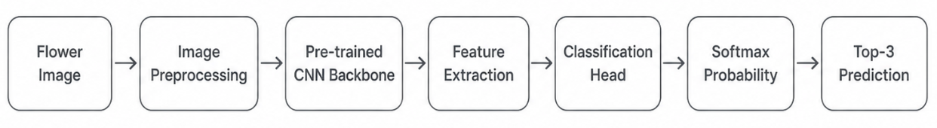
Figure 3-1: Overall process of flower recognition
From the perspective of the implementation process, the flower recognition method in this paper mainly includes three stages : the first is the data processing stage, which completes image loading, data enhancement, size unification and normalization ; the second is the model training stage, which replaces the classification head based on the pre-trained CNN, and uses a two-stage fine-tuning strategy to train the model ; the third is the model inference stage, which integrates the trained EfficientNet-B0 into the back-end service to provide the flower recognition ability for the Web system.

3.2 Data Processing
Data processing is an important basis for flower recognition model training. For the image classification task, the size of the input image, the enhancement method, the normalization method and the data division will affect the model training effect. Flower images have the characteristics of similarity between classes and obvious differences within classes. For example, different categories of flowers may have similar colors and shapes, while the same category of flowers may also show great differences due to different illumination, angle, background and openness. Therefore, it is necessary to process the images uniformly before the model training, and increase the data changes appropriately in the training stage to improve the generalization ability of the model.
The data processing process of this paper mainly includes five parts : data set introduction, data set division, image preprocessing, data enhancement and data normalization. In the program implementation, PyTorch and torchvision are used to complete data loading and transform processing. The training set adopts a data enhancement strategy with random disturbance, and the verification set and test set adopt a deterministic preprocessing method to ensure the stability of the evaluation results.

3.2.1 Dataset Introduction
In this paper, Oxford 102 Flowers data set is used for model training, verification and testing. The dataset contains 102 flower categories, covering a variety of common flower types, such as rose, sunflower, lotus, camellia, hibiscus, etc. The images in the dataset are different in shooting angle, background environment, image scale and lighting conditions, so it can better simulate the complex situations that may occur when users upload flower images in real scenes.
Compared with ordinary image classification, flower recognition has certain fine-grained classification characteristics. There may be similar colors, petal shapes and overall contours between different flower categories, and within the same category may vary greatly due to different shooting conditions. This requires the model not only to pay attention to shallow information such as color, but also to learn deeper texture, local structure and semantic features. The Oxford 102 Flowers dataset was originally used to study the automatic flower classification problem under the condition of large number of categories [2], which is in line with the task goal of the Web flower recognition system in this paper.

3.2.2 Dataset Split
In terms of data set division, this paper adopts the official division method provided by Oxford 102 Flowers instead of self-random division. The official division includes three parts : training set, validation set and test set. In this paper, the corresponding data are loaded by split = ‘ train ’, split = ‘ val ’ and split = ‘ test ’ in the code to ensure the standardization and reproducibility of the experimental process.
Table 3-1: Official split of Oxford 102 Flowers dataset
Dataset Split | Number of Images | Description
Training Set | 1020 | Used for model training
Validation Set | 1020 | Used for model selection
Test Set | 6149 | Used for final evaluation
The use of official division can avoid the contingency caused by random division and make the comparison between different models more fair. Among them, the validation set is used for model selection in the training process, and the test set is used to evaluate the generalization ability of the model on the data that is not involved in training and model selection. Because there are only 10 images in each category in the training set, this paper does not train the model from scratch, but uses the transfer learning method based on the ImageNet pre-training model to alleviate the problem of insufficient training samples [12][13].

3.2.3 Image Preprocessing
The main purpose of image preprocessing is to convert original images of different sizes and formats into unified input that the model can accept. The MobileNetV2, ResNet18 and EfficientNet-B0 selected in this paper are typical convolutional neural network models, so it is necessary to uniformly process the input image into a fixed size tensor. According to the experimental configuration, the input image size is set to 224×224, and the number of categories is set to 102.
In the training stage, the image will be first adjusted in size, and then the training samples will be generated by random clipping. In the verification and testing phase, in order to ensure the stability of the evaluation results, this paper adopts a fixed size adjustment and center cutting method. All images will eventually be converted to tensors and normalized.
Table 3-2: Image preprocessing strategies for training, validation and test sets
Stage | Preprocessing Strategy | Purpose
Training | Resize, RandomResizedCrop, RandomHorizontalFlip, RandomRotation, ColorJitter, GaussianBlur, ToTensor, Normalize | Improve generalization
Validation | Resize, CenterCrop, ToTensor, Normalize | Model selection
Test | Resize, CenterCrop, ToTensor, Normalize | Final evaluation
This approach takes into account the data diversity in the training phase and the stability in the evaluation phase. Adding random changes to the training set helps to reduce the dependence of the model on fixed shooting angle, background and color distribution. The verification set and the test set do not use random enhancement, which can ensure that the experimental results have good repeatability.

3.2.4 Data Augmentation
Due to the small scale of Flowers102 training set, it is easy to over-fit if the depth model is trained directly using the original image. In order to enhance the adaptability of the model to the real scene, this paper introduces a variety of data enhancement methods in the training stage, including random cropping, random horizontal flipping, random rotation, color jitter and Gaussian blur.
For data augmentation, random cropping is used to simulate the situation of flowers in different scales and positions in the image. Random horizontal flipping is used to enhance the robustness of the model to direction changes. Random rotation is used to simulate the angle offset of the user’s shooting ; color jitter is used to simulate different illumination, contrast and saturation conditions. Gaussian blur is used to enhance the adaptability of the model to slightly defocused images. The relevant parameters are shown in Table 3-3.
Table 3-3: Data augmentation methods used in the training set
Augmentation Method | Setting | Function
RandomResizedCrop | scale=(0.8, 1.0), size=224 | Simulate scale and position changes
RandomHorizontalFlip | p=0.5 | Improve direction robustness
RandomRotation | 15° | Simulate shooting angle changes
ColorJitter | brightness=0.2, contrast=0.2, saturation=0.2 | Simulate color and illumination changes
GaussianBlur | kernel_size=3, p=0.3 | Improve robustness to slight blur
It should be noted that data augmentation is only used for training sets, not for validation sets and test sets. This can not only improve the diversity of training samples, but also ensure the stability and fairness of the model evaluation process.

3.2.5 Data Normalization
Data normalization is used to unify the numerical distribution of image input and improve the stability of model training. In this paper, we use the standardized parameters of the ImageNet dataset to normalize the RGB three channels. The specific settings are as follows :
mean = [0.485, 0.456, 0.406]
std = [0.229, 0.224, 0.225]
The normalized calculation method is as follows :
$$x' = \frac{x − μ}{σ}$$
Among them, $x$ represents the pixel value before normalization, $μ$ represents the mean value of the corresponding channel, $σ$ represents the standard deviation of the corresponding channel, and $x'$ represents the normalized pixel value.
In this paper, ImageNet standardized parameters are used because MobileNetV2, ResNet18 and EfficientNet-B0 are all based on ImageNet pre-training weights for transfer learning. By using the normalization method consistent with the pre-training stage, the input distribution can be closer to the original data distribution of the pre-training model, so as to make full use of the general visual features learned by the pre-training model [13]. In summary, this paper provides a stable data basis for subsequent model training and experimental comparison through official data division, data enhancement in training stage, unified size processing and standardized normalization.

3.3 Architecture of Flower Recognition Model
This section mainly introduces the structural design of the flower recognition model in this paper. Combined with the overall recognition process shown in Figure 3-1, the model part mainly includes pre-trained convolutional neural network backbone, feature extraction, classification head, Softmax probability calculation and Top-3 prediction output. Due to the limited number of training samples in Oxford 102 Flowers dataset, this paper does not train the deep convolutional neural network from scratch, but uses the transfer learning method to load the ImageNet pre-training weight, and replaces the final classification layer of the original model with a new classification head suitable for 102 flower classification tasks. Previous studies have shown that the low-level visual features learned in deep neural networks have certain transferability, and the rational use of pre-trained features can improve the training efficiency and generalization ability of target tasks [12] [29].
In terms of specific model selection, this paper selects three classical convolutional neural networks, MobileNetV2, ResNet18 and EfficientNet-B0, as candidate pre-trained backbone networks, and conducts comparative experiments under unified data processing methods and training strategies.

3.3.1 Problem Formulation
The flower recognition task in this paper can be defined as a 102-class image classification problem. Let the input flower image be x, and its true category label be y, where y∈{ 1,2,..., 102 }. The model extracts image features through a convolutional neural network and outputs a 102-dimensional prediction vector :
$$z=f_{θ}(x), z∈ℝ^{102}$$
Among them, $f_{θ}$ represents the flower recognition model with parameter $θ$, and $z$ represents the logits output by the model. In order to convert logits into probability distributions for each class, we use the Softmax function to normalize them. The calculation is as follows :
$$p_{i}=\frac{e^{z_{i}}}{\sum_{j=1}^{102}{e^{z_{j}}}}$$
Here, $p_{i}$ represents the probability that the input image belongs to the i th flower category. The final model prediction category is the category with the highest probability :
$$\hat{y}=\arg{\max_{i}{p_{i}}}$$
In the training process, this paper uses the cross entropy loss function to measure the difference between the model prediction results and the real labels. For a single sample, the loss function can be expressed as :
$$L=−\sum_{i=1}^{102}{y_{i}}\log{(}p_{i})$$
Among them, $y_{i}$ represents the one-hot coding of the real label, and $p_{i}$ represents the category probability predicted by the model. Cross entropy loss is a commonly used loss function in multi-category classification tasks, which can effectively guide the model to learn the discriminant boundary between different categories [30].

3.3.2 Pre-trained CNN Backbone
In the process shown in Figure 3-1, the pre-trained CNN backbone network is located after image preprocessing, which is mainly responsible for receiving standardized flower images and extracting discriminative visual features. This paper does not directly design a new convolutional network structure, but based on the idea of transfer learning, selects the existing classical pre-training model as the feature extraction backbone. This can make full use of the general visual features learned by the model on large-scale image data sets, such as edges, textures, color changes, local shapes, and high-level semantic structures.
In this paper, MobileNetV2, ResNet18 and EfficientNet-B0 are selected as candidate backbone networks, mainly to compare the performance of different types of convolutional networks in flower recognition tasks.
(1) MobileNetV2
MobileNetV2 is a convolutional neural network designed for mobile and lightweight scenarios. Its core structure includes an inverted residual structure and a linear bottleneck structure. The model reduces the amount of parameters and calculations through deep separable convolution, and reduces the complexity of the model while maintaining a certain classification ability [4]. Therefore, MobileNetV2 is suitable as a lightweight comparison model in the flower recognition task.
In the implementation of this paper, MobileNetV2 loads ImageNet pre-training weights and retains its original feature extraction part. Since the classification layer of the original model does not apply to the Oxford 102 Flowers dataset, this paper replaces its final classifier with a new classification head with an output dimension of 102, so that it can complete the 102 flower classification task. The advantage of MobileNetV2 is that the parameters are small and suitable for resource-constrained environments.
(2) ResNet
ResNet is a classic residual network structure. Its core idea is to construct a residual learning module through shortcut connection, thereby alleviating the problem of gradient disappearance and network degradation during deep neural network training [3]. ResNet18 is a shallow structure in the ResNet series. It has the characteristics of stable training, clear structure and good classification performance. Therefore, it is often used as a baseline model in image classification tasks.
ResNet18 used in this paper also loads ImageNet pre-training weights. For 102 kinds of flower recognition tasks, this paper replaces the original fully connected classification layer of ResNet18 with a fully connected layer with an output dimension of 102. Compared with MobileNetV2, ResNet18 has stronger feature expression ability, but its parameter quantity is also significantly larger.
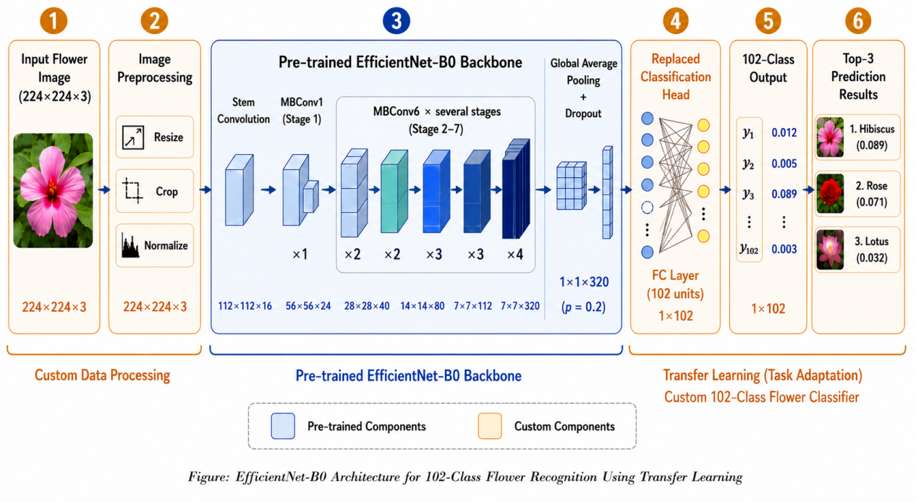
Figure 3-2: EfficientNet-B0 Architecture for 102-Class Flower Recognition
(3) EfficientNet
EfficientNet is a convolutional neural network based on composite scaling strategy. Different from the method of only increasing the network depth, width or input resolution, EfficientNet balances the network depth, width and input resolution at the same time, thereby improving the efficiency of parameter utilization [5]. EfficientNet-B0 is the basic model of EfficientNet series, which has the characteristics of moderate parameters, good classification performance and high computational efficiency.
This paper finally chooses EfficientNet-B0 as the system deployment model. On the one hand, the number of parameters of EfficientNet-B0 is significantly lower than that of ResNet18, which is conducive to reducing the resource consumption in the system reasoning stage ; on the other hand, in the experiment of this paper, the accuracy of the validation set and the accuracy of the test set of EfficientNet-B0 are higher than those of MobileNetV2 and ResNet18, indicating that it has better comprehensive performance in the current flower recognition task.
Figure 3-2 illustrates the overall architecture of the flower recognition model based on transfer learning using EfficientNet-B0. The model first performs image preprocessing operations, including resizing, cropping, and normalization, to standardize the input flower images. The processed images are then fed into the pre-trained EfficientNet-B0 backbone, which extracts deep visual features through multiple MBConv layers. To reduce model complexity and improve generalization ability, Global Average Pooling and Dropout are applied before the classification stage. Finally, the original ImageNet classification head is replaced with a custom fully connected layer for 102-class flower classification, and the model outputs the Top-3 prediction results with corresponding probabilities. This architecture effectively combines the strong feature extraction capability of the pre-trained model with task-specific adaptation for flower recognition.

3.3.3 Feature Extraction
Feature extraction corresponds to the ‘ Feature Extraction ’ link in Figure 3-1. After image preprocessing and standardization, flower images are input into the pre-trained CNN backbone network. The backbone network gradually converts the original image into a more abstract feature representation through multi-layer convolution, nonlinear activation and down-sampling operations.
Different from the traditional methods that rely on manual design of color, texture and shape features, the deep learning method used in this paper automatically completes feature extraction by convolutional neural networks. Shallow convolution usually pays more attention to edges, color changes, textures and simple local structures ; the high-level convolution can learn petal shape, heart structure, local texture combination and more advanced semantic information.
For flower recognition tasks, these features help the model to distinguish flowers with similar appearance but different categories. In the transfer learning scenario, the pre-trained model has learned more general visual features on large-scale image datasets such as ImageNet.
In this paper, by loading pre-training weights, the model can obtain better initial feature expression ability under small sample training conditions. Then, through a two-stage fine-tuning strategy, the features extracted by the backbone network are further adapted to the flower image distribution in the Oxford 102 Flowers dataset.

3.3.4 Classification Head
The classification head corresponds to the ‘ Classification Head ’ link in Figure 3-1. The original classification head of the pre-trained model is usually used for the 1000-class classification task of ImageNet, and cannot be directly used for the 102-class flower classification task of Oxford 102 Flowers. Therefore, in the process of model structure adaptation, this paper retains the pre-trained CNN backbone network and replaces its final classification layer, so that the output dimension of the model is consistent with the number of flower categories.
For MobileNetV2, this paper retains its feature extraction part and replaces the final classifier with a new classification structure suitable for 102 classification tasks. For ResNet18, this paper replaces its original fully connected layer with a fully connected layer with an output dimension of 102. For EfficientNet-B0, this paper replaces the last linear layer in the classifier with a new 102-class output layer. In this way, the three candidate models can be trained and compared under the same number of categories.
The main function of the classification head is to map the image features extracted by the backbone network to the prediction scores of each flower category. The feature vector of the backbone network output is set to h, and the classification head can be expressed as :
$$z=Wh+b$$
Among them, W and b represent the weight matrix and bias term in the classification head, respectively, and z represents the 102-dimensional logits output. Each dimension corresponds to the predicted score of a flower category. Then, the model converts logits into a probability distribution through the Softmax function, and generates the final prediction result according to the probability size.
The classification head is a key part of the model transformation in this paper. By replacing the classification head, the pre-training model can be transformed from the original general image classification task to the 102-class flower recognition task in this paper. In the first stage of training, this paper freezes the backbone network and only trains the newly replaced classification heads, so that the classification heads can quickly adapt to the category distribution of Flowers102. In the second stage of training, all network layers are thawed for overall fine-tuning.

3.3.5 Two-stage Fine-tuning Strategy
In order to make full use of the general visual features of the pre-trained model and reduce the risk of overfitting caused by small sample training, this paper adopts a two-stage fine-tuning strategy. In the first stage, the feature extraction layer of the pre-training model is frozen, and only the newly replaced classification head is trained. In the second stage, on the basis of loading the best model of the first stage, all network layers are thawed and the whole model is fine-tuned with a smaller learning rate.
The goal of the first stage is to make the new classification head quickly adapt to the 102-class classification task of Flowers102. At this stage, the model backbone network parameters remain unchanged, and only the final classification layer parameters are updated. This can avoid destroying the general visual features that the pre-trained model has learned at the beginning of training. The goal of the second stage is to further adjust the entire network at a smaller learning rate, so that the underlying and high-level features of the model are more suitable for flower recognition tasks. This strategy is suitable for scenarios where the number of training samples is small but the target task and the original pre-training task belong to the field of image classification.
The specific settings of the two-stage fine-tuning strategy in this paper are shown in Table 3-4.
Stage | Trainable Layers | Max Epochs | Learning Rate | Optimizer | Scheduler
Stage 1 | Classification head only | 20 | 1e-3 | Adam | None
Stage 2 | All layers | 60 | 1e-5 | Adam | ReduceLROnPlateau
Table 3-4: Settings of two-stage fine-tuning strategy
In this paper, Adam optimizer is used in the training process. Adam can adaptively adjust the parameter update step size according to the first-order moment and second-order moment estimation of the gradient, and has good stability and high practical value in deep learning model training [31]. In the second stage, this paper further uses the ReduceLROnPlateau learning rate scheduling strategy to reduce the learning rate when the accuracy of the verification set has not been significantly improved for a long time, so as to help the model obtain a more stable convergence effect in the fine-tuning stage.

3.3.6 Top-3 Prediction
In the system inference stage, this paper not only returns the single prediction category with the highest probability, but also designs the Top-3 prediction output mechanism. After the model completes the forward propagation of the input image, it will get logits corresponding to 102 categories. Subsequently, the system uses Softmax to convert it into a probability distribution, and selects the three categories with the highest probability and their confidence as the output results.
The Top-3 output mechanism is suitable for flower recognition tasks. Because some flower categories are similar in color, petal structure and overall shape, a single category output may not fully express the uncertainty of model judgment. By returning the first three candidate categories, users can more intuitively understand the model’s judgment of similar categories, and it is also convenient for the subsequent system to display relevant flower information in combination with the popular science knowledge module.
Step | Description
Input | Flower image and trained EfficientNet-B0 model
1 | Resize, crop, tensorize and normalize the input image
2 | Feed the image into the trained model
3 | Apply Softmax to obtain class probabilities
4 | Select the top-3 classes with the highest probabilities
Output | Class names and confidence scores
Algorithm 3-1: Top-3 prediction process
It should be noted that the Top-3 of this paper is mainly used for system results display, rather than experimental evaluation indicators. The experimental part of this paper mainly uses the accuracy of the verification set, the accuracy of the test set and the loss value to analyze the model performance.

3.4 Experiments and Analysis
This section analyzes the experimental results of the flower recognition model. The experimental content mainly includes experimental environment description, evaluation criteria, ablation study, comparison with different models, training curve analysis, confusion matrix analysis and comprehensive model analysis. In order to ensure the fairness of model comparison, MobileNetV2, ResNet18 and EfficientNet-B0 all adopt the same dataset split, image preprocessing method and training strategy. Through the experimental results, this paper analyzes the recognition performance of different models on the Flowers102 dataset, verifies the influence of data augmentation and fine-tuning strategy, and further analyzes the error sources of the final model through confusion matrix and confused class pairs.

3.4.1 Experimental Environment
The experiment is completed in a GPU environment that supports CUDA acceleration. Model training and testing are based on the PyTorch framework. Data set loading and image preprocessing are performed using the torchvision tool. The specific experimental environment and main training parameters are shown in Table 3-5.
Item | Configuration
GPU | NVIDIA GeForce RTX 3050
Python | 3.10.20
PyTorch | 2.5.1
CUDA | pytorch-cuda 12.1
Dataset | Oxford 102 Flowers
Input Size | 224×224
Batch Size | 32
Stage 1 Max Epochs | 20
Stage 2 Max Epochs | 60
Best Model Saving | Best validation accuracy checkpoint
Loss Function | CrossEntropyLoss
Optimizer | Adam
Final Model | EfficientNet-B0
Table 3-5: Experimental environment and training settings
During the experiment, the training set is used for model parameter learning, the validation set is used for model selection in the training phase, and the test set is used for the final model generalization ability evaluation. Each candidate model uses ImageNet to pre-train weights and replaces the final classification layer with an output layer suitable for 102 flower classification tasks.

3.4.2 Evaluation Criteria
This paper mainly uses accuracy, loss curve, confusion matrix and confused class pairs to evaluate the performance of the flower recognition model. Accuracy is used to measure the proportion of correctly classified samples among all samples, which is defined as:
$$Accuracy=\frac{N_{correct}}{N_{total}}×100\%$$
Among them, $N_{correct}$ represents the number of correctly classified samples, and $N_{total}$ represents the total number of samples. In this paper, the verification accuracy is used to monitor the training process and select the best checkpoint, while the test accuracy is used to evaluate the generalization ability of the final model.
Loss is used to observe the convergence of the model during training. Since the cross entropy loss has been defined in Section 3.3.1, the formula is not repeated in this section. In the experimental analysis, the training loss and verification loss curves are used to determine whether the model converges normally and whether there is a significant over-fitting phenomenon.
In addition, this paper also uses the confusion matrix to further analyze the classification errors of the final deployment model. For classification tasks with C categories, the confusion matrix can be expressed as :
$$M=[m_{ij}]_{C×C}$$
Here, $m_{ij}$ denotes the number of samples whose real class is i but predicted to be class j. The diagonal element $m_{ii}$ represents the correctly classified sample, while the non-diagonal element represents the misclassified sample.
In order to make the confusion relationship between different categories clearer, this paper also uses a normalized confusion matrix. The definition of normalization method is as follows :
$${\hat{m}}_{ij}=\frac{m_{ij}}{\sum_{j=1}^{C}{m_{ij}}}$$
where ${\hat{m}}_{ij}$ represents the normalized value of row i and column j. Based on the confusion matrix, this paper further counts the category pairs with higher misclassification times, and obtains the top 10 most confusing category pairs. These results are used to analyze which flower categories are more likely to be confused by the model.

3.4.3 Ablation Study
To further verify the effectiveness of the main training settings, this paper conducts an ablation study on EfficientNet-B0. The full method uses random data augmentation and the two-stage fine-tuning strategy. In the first ablation setting, random data augmentation is removed, while the model structure and two-stage fine-tuning strategy remain unchanged. In the second ablation setting, only the replaced classification head is trained, and the backbone network remains frozen during the whole training process.
The experimental results are shown in Table 3-6. The full method achieves the best overall performance, with a validation accuracy of 89.80% and a test accuracy of 87.45%. After removing random data augmentation, the validation accuracy only decreases slightly from 89.80% to 89.41%, but the test accuracy decreases from 87.45% to 86.01%. This indicates that random data augmentation mainly improves the generalization ability of the model on unseen test images.
Method | Val Acc | Test Acc | Stop Epoch | Observation
Full Method | 89.80% | 87.45% | 20 + 60 | Best overall performance
Without Data Augmentation | 89.41% | 86.01% | 20 + 60 | Lower test generalization
Classifier Head Only | 85.78% | 82.60% | 20 + 60 | Insufficient feature adaptation
Table 3-6: Ablation Study of EfficientNet-B0
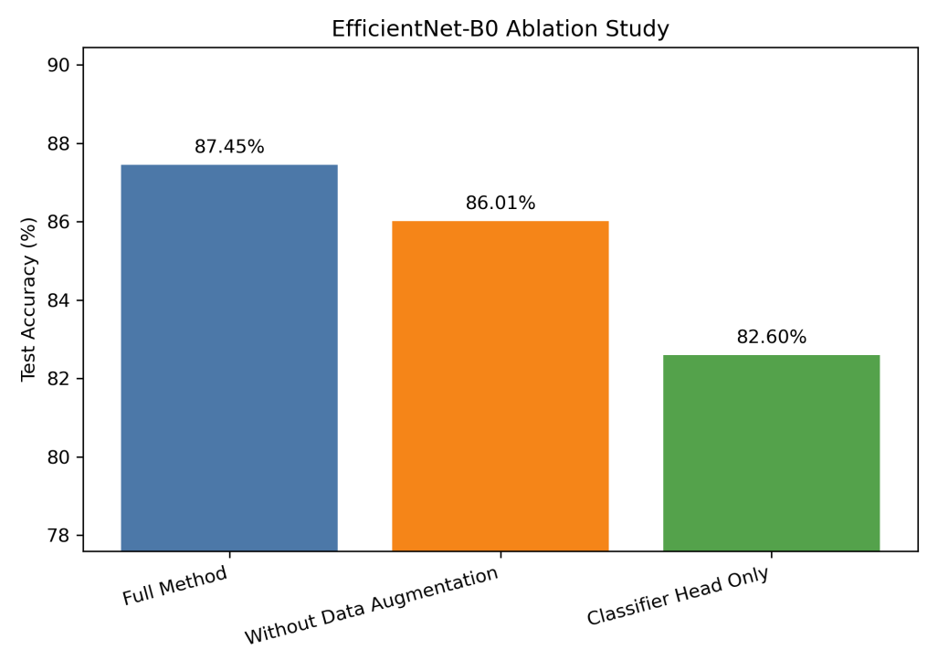
Figure 3-3: Test Accuracy of Different Ablation Settings on EfficientNet-B0
Figure 3-3 further shows the test accuracy comparison of different ablation settings. When only the classification head is trained, the test accuracy drop to 82.60%, respectively. This result shows that only adapting the classification head is not sufficient for the fine-grained flower recognition task. Although the pre-trained backbone has learned general visual features, full fine-tuning is still necessary to make the feature extraction layers better adapt to the visual differences among 102 flower categories.

3.4.4 Comparison with Different Models
To select the flower recognition model suitable for system deployment, this paper compares the three models MobileNetV2, ResNet18 and EfficientNet-B0. The three models all use the same data processing method, the same data set division and the same two-stage fine-tuning strategy. The experimental results are shown in Table 3-7.
Model | Parameters | Stage 2 Epochs | Best Validation Accuracy | Test Accuracy
MobileNetV2 | 2.3M | 60 | 88.14% | 85.07%
ResNet18 | 11.2M | 60 | 89.02% | 86.81%
EfficientNet-B0 | 4.1M | 60 | 89.80% | 87.45%
Table 3-7: Comparison of different classification models
It can be seen from Table 3-7 that EfficientNet-B0 achieves the best overall results among the three models. The best verification accuracy rate is 89.80%, and the test accuracy rate is 87.45%. MobileNetV2 has the least number of parameters, only about 2.3 million, but its test accuracy is 85.07%, which is lower than the other two models. The verification accuracy of ResNet18 is 89.02%, and the test accuracy is 86.81%, but the number of parameters reaches 11.2 million, which is significantly more than EfficientNet-B0.
On the whole, EfficientNet-B0 achieves a good balance between parameter quantity and accuracy. Its parameter quantity is about one-third of ResNet18, but the accuracy of the validation set and the test set is higher than that of ResNet18. At the same time, compared with MobileNetV2, EfficientNet-B0 has a slightly higher parameter quantity, but the accuracy improvement is more obvious. Therefore, this paper finally chooses EfficientNet-B0 as the deployment model of flower intelligent recognition system.

3.4.5 Training Curve Analysis
In order to further analyze the training process of EfficientNet-B0, this paper draws the accuracy curve and loss curve of the model in two training stages. Among them, Stage 1 represents the stage of freezing the feature extraction layer and only training the classification head ; stage 2 represents the stage of unfreezing all network layers and fine-tuning the whole model. By observing the two-stage training curve, the influence of the two-stage fine-tuning strategy on the convergence process and recognition performance of the model can be analyzed more intuitively.

- Accuracy curves of EfficientNet-B0
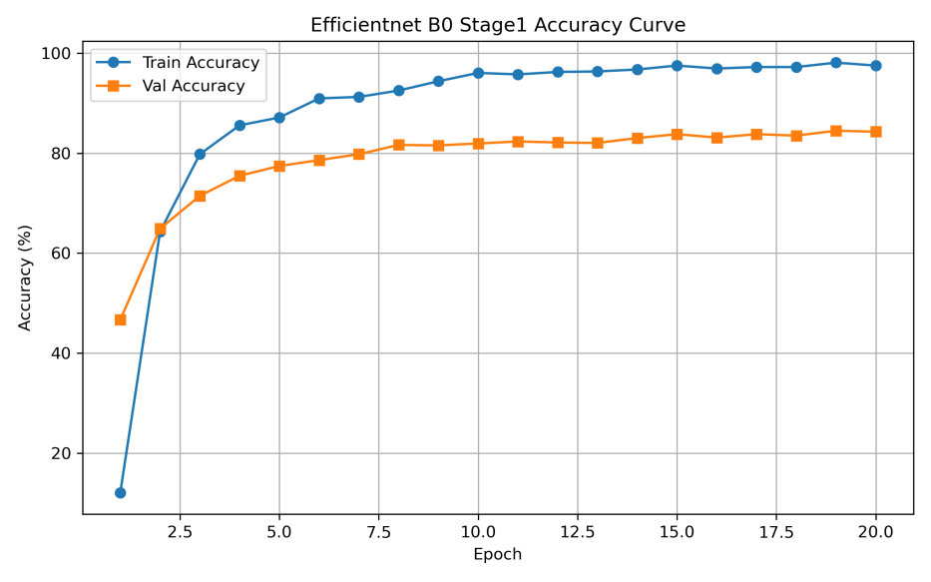
(1)
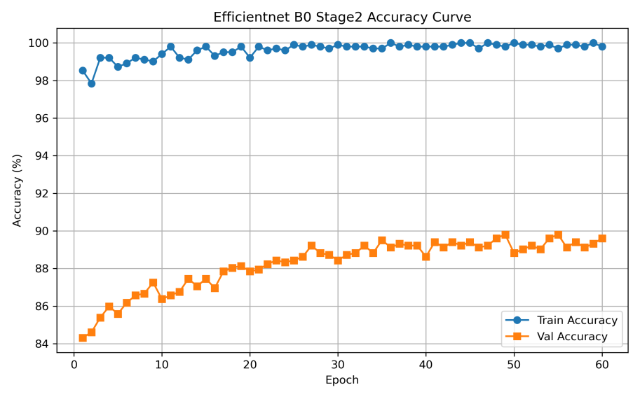
(2)
Figure 3-4: Accuracy curves of EfficientNet-B0 during training
Figure 3-4 shows the accuracy changes of EfficientNet-B0 in Stage 1 and Stage 2. Stage 1 freezes the feature extraction layer and only trains the newly replaced classification heads. It can be seen that the model training accuracy and verification accuracy increase rapidly in the early stage, indicating that the ImageNet pre-training model has a strong general visual feature extraction ability, and only training the classification head can quickly adapt to the classification task of Flowers102. The best verification accuracy of EfficientNet-B0 in Stage 1 reached 84.51%.
Entering Stage 2, the model thawed all network layers and fine-tuned the whole with a smaller learning rate. The training accuracy is maintained at a high level, and the verification accuracy continues to improve in fluctuation. The best verification accuracy reaches 89.80%. Compared with Stage 1, Stage 2 improves the performance of the model, indicating that fine-tuning the whole model can make the feature extraction layer better adapt to the fine-grained features of flower images.
- Loss curves of EfficientNet-B0
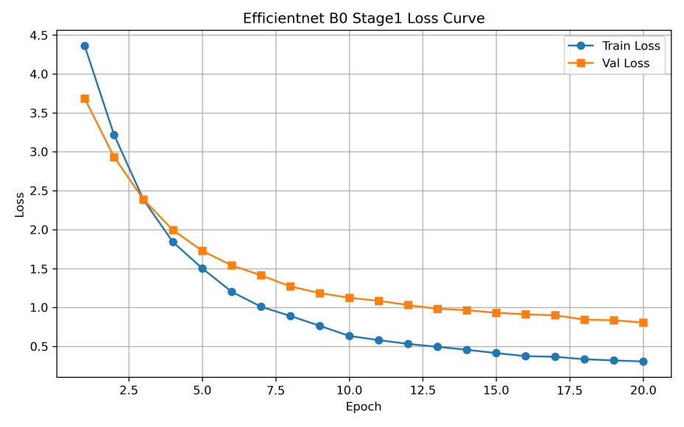
(1)
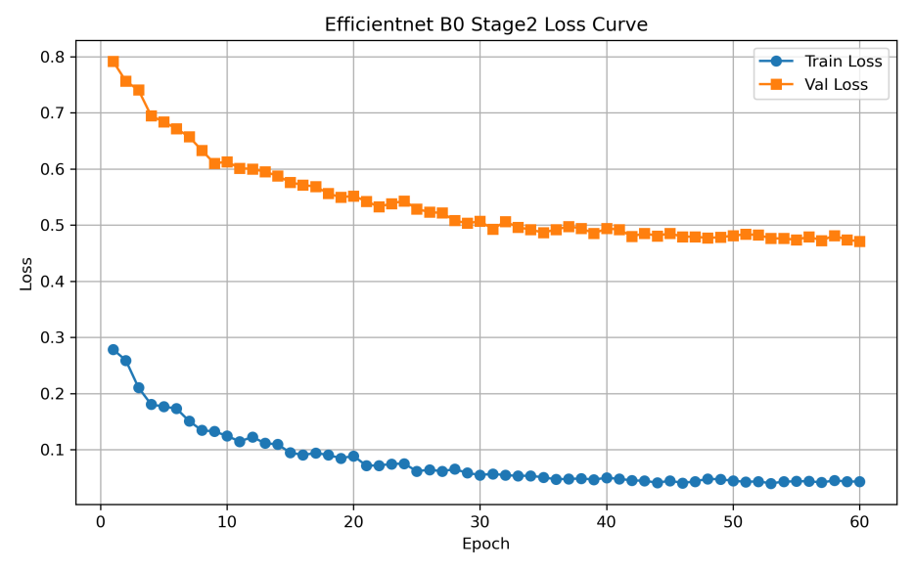
(2)
Figure 3-5: Loss curves of EfficientNet-B0 during training
Figure 3-5 shows the training loss and verification loss changes of EfficientNet-B0 in two stages. In Stage 1, the overall training loss and verification loss decreased rapidly, indicating that the classification head could learn the discriminant relationship between flower categories faster. With the increase of training rounds, the speed of loss decline gradually slows down, and the model enters a relatively stable state.
In Stage 2, the training loss continued to decline and remained at a low level, and the verification loss also showed a downward trend as a whole, but there were some fluctuations in the later period. Due to the small scale of Flowers102 training set, it is normal that the training loss is lower than the verification loss. The verification loss does not continue to rise, indicating that data enhancement, small learning rate fine-tuning alleviate the overfitting problem to a certain extent.
- Stage 2 validation accuracy comparison of different models
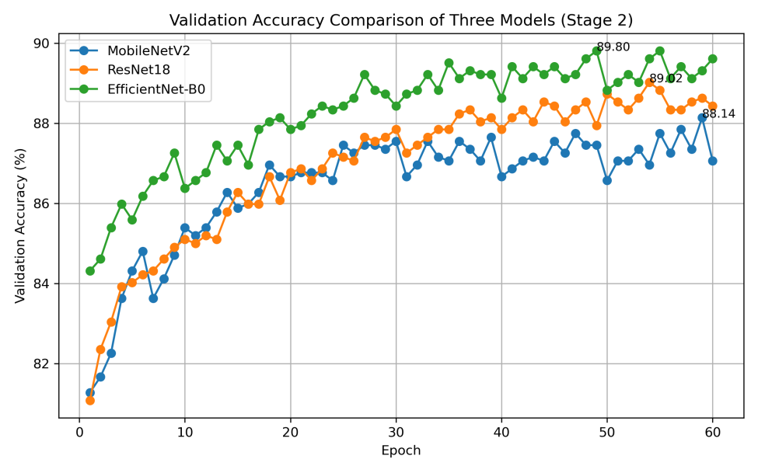
Figure 3-6: Stage 2 validation accuracy comparison of different models
Figure 3-6 shows the verification accuracy changes of MobileNetV2, ResNet18 and EfficientNet-B0 during the second stage of fine-tuning. It can be seen that the verification accuracy of the three models in Stage 2 is on the rise as a whole, indicating that the fine-tuning of the whole model has a certain improvement effect on different pre-training models. Among them, EfficientNet-B0 maintains the highest verification accuracy in most epochs, and finally achieves the best verification accuracy of 89.80%, which is higher than 88.14% of MobileNetV2 and 89.02% of ResNet18.
On the whole, EfficientNet-B0 can quickly complete task adaptation by training the classification head in Stage 1, and further improve the performance of the verification set by fine-tuning the whole model in Stage 2. Both the Accuracy curve and the loss curve show that the model training process is relatively stable, and there is no obvious phenomenon of training out of control. Therefore, the two-stage fine-tuning strategy can effectively improve the recognition ability of the model on the Flowers102 dataset.

3.4.6 Confusion Matrix and Confused Class Pairs Analysis
In order to further analyze the source of classification errors of EfficientNet-B0, this paper draws a normalized confusion matrix on the test set, and counts the top 10 groups of easily confused category pairs with the highest number of misclassifications. Compared with the overall accuracy, the confusion matrix can more intuitively show the misjudgment of the model between different flower categories, which is helpful to analyze the shortcomings of the model in the fine-grained classification task.
Figure 3-7 shows the normalized confusion matrix of EfficientNet-B0 on the test set. It can be seen from the figure that the color of the diagonal region of the matrix is significantly darker, indicating that most test samples can be correctly classified. The overall color of the non-diagonal region is lighter and the distribution is more dispersed, indicating that the model does not have a wide range of systematic misjudgment. Since the Oxford 102 Flowers dataset contains 102 categories, the complete confusion matrix has a large dimension, and the details of a single category in the figure are difficult to fully display. Therefore, this paper further analyzes the confusing categories.
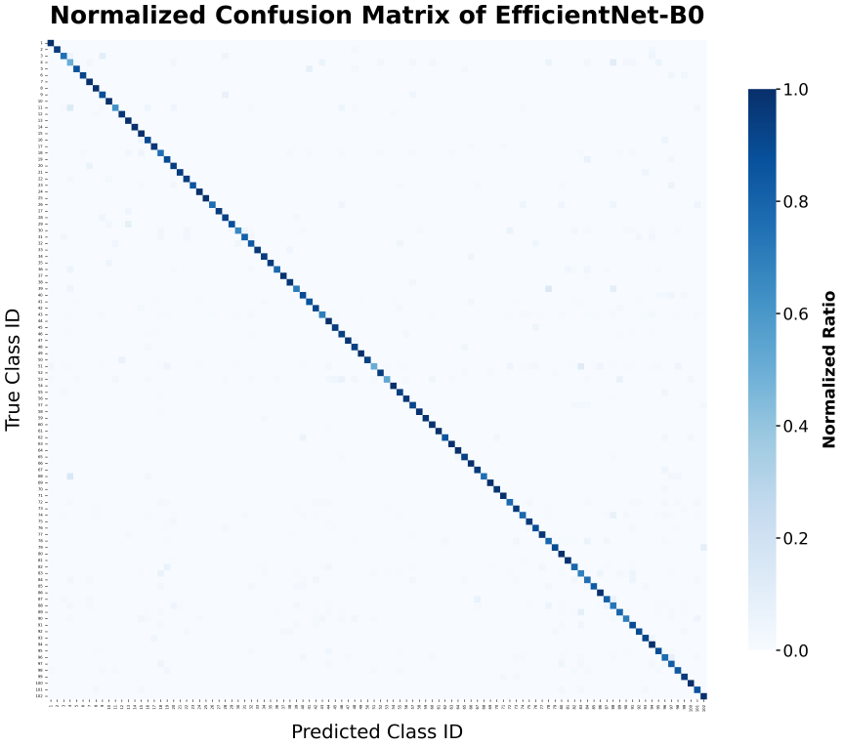
Figure 3-7: Normalized confusion matrix of EfficientNet-B0 on the test set
Figure 3-8 shows the top 10 class pairs with the highest number of misclassifications in EfficientNet-B0. The graph is sorted from high to low according to the number of misclassified samples, which can intuitively reflect which categories the model is more prone to judgment errors. In order to further show the specific values, Table 3-8 gives the corresponding real category, prediction category, number of misclassified samples and error ratio.
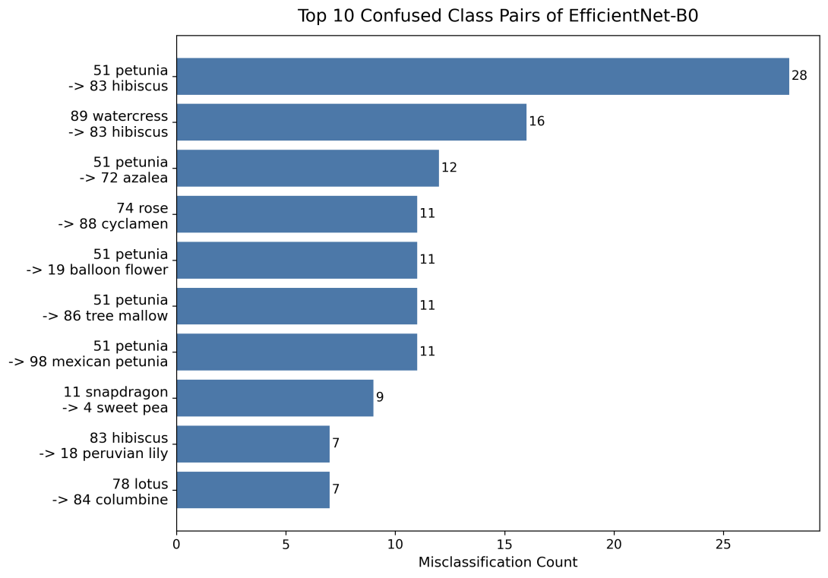
Figure 3-8: Top 10 confused class pairs of EfficientNet-B0 by misclassification count

Rank | Class | Predicted Class | Misclassified Samples | Error Ratio
1 | petunia | hibiscus | 28 | 11.76%
2 | watercress | hibiscus | 16 | 9.76%
3 | petunia | azalea | 12 | 5.04%
4 | rose | cyclamen | 11 | 7.28%
5 | petunia | balloon flower | 11 | 4.62%
6 | petunia | tree mallow | 11 | 4.62%
7 | petunia | mexican petunia | 11 | 4.62%
8 | snapdragon | sweet pea | 9 | 13.43%
9 | hibiscus | peruvian lily | 7 | 6.31%
10 | lotus | columbine | 7 | 5.98%
Table 3-8: Top 10 confused class pairs of EfficientNet-B0
From Figure 3-8 and Table 3-8, it can be seen that petunia appears more frequently in confusing category pairs. For example, petunia is misclassified as hibiscus, azalea, balloon flower, tree mallow and mexican petunia. On the one hand, this is because petunia has a large number of samples in the test set, which is more likely to appear in the forefront when sorted according to the number of misclassifications ; on the other hand, these categories have certain similarities in corolla shape, petal color and overall contour, which increases the difficulty of model distinction.
In addition, although the number of misclassifications of snapdragon misclassified as sweet pea is not the highest, its error ratio reaches 13.43%, indicating that some categories still have a high degree of confusion compared with the total number of samples in this category, even if the total number of misclassifications is not large.
This indicates that the model’s errors in some categories mainly come from the lack of fine-grained visual differences, rather than simple background interference or overall recognition failure. In general, the analysis of confusion matrix and easily confused category pairs shows that the main error source of EfficientNet-B0 is fine-grained confusion between flower categories with similar appearance.

3.4.7 Analysis of Flower Recognition Model
According to the model comparison results, ablation study, training curves and confusion matrix analysis, the transfer learning and two-stage fine-tuning strategy used in this paper are suitable for the Oxford 102 Flowers classification task. Since the training samples of this dataset are limited, directly training a deep convolutional neural network from scratch may easily lead to overfitting. By loading ImageNet pre-trained weights, the model can inherit general visual features such as edges, textures, shapes and local structures, and then gradually adapt to flower recognition through classification head training and full fine-tuning [12][13][29].
The ablation study further shows the effectiveness of the main training settings. Removing random data augmentation causes the test accuracy to drop from 87.45% to 86.01%, indicating that data augmentation helps improve the model’s generalization ability on unseen images. When only the classification head is trained, the test accuracy drops to 82.60%, which shows that full fine-tuning is necessary for adapting the feature extraction layers to fine-grained flower differences.
From the comparison of different models, MobileNetV2 has the smallest number of parameters, but its test accuracy is relatively low. ResNet18 achieves better accuracy, but its parameter size is much larger. EfficientNet-B0 achieves the best test accuracy of 87.45% with about 4.1M parameters, showing a good balance between recognition performance and model size. Therefore, EfficientNet-B0 is selected as the final flower recognition model for system deployment.
The confusion matrix and confused class pairs analysis show that most classification errors occur between flower categories with similar appearance. This indicates that the remaining errors mainly come from fine-grained visual confusion rather than overall model failure. In general, the final model has good recognition ability and is suitable for integration into the Web-based flower recognition and popular science system.

3.5 Chapter Summary
This chapter focuses on the construction and experimental analysis of the flower recognition model. Firstly, the overall recognition process is introduced, including image preprocessing, pre-trained CNN feature extraction, classification head output, Softmax probability calculation and Top-3 prediction result generation.
Secondly, this chapter introduces the Oxford 102 Flowers dataset and the data processing methods used in this paper. The official training, validation and test splits are adopted, and data augmentation methods such as random cropping, random flipping, random rotation, color jitter and Gaussian blur are used in the training phase to improve the generalization ability of the model.
Then, MobileNetV2, ResNet18 and EfficientNet-B0 are trained and compared using transfer learning and two-stage fine-tuning. The experimental results show that EfficientNet-B0 achieves the best overall performance, with a validation accuracy of 89.80% and a test accuracy of 87.45%. The ablation study further verifies that random data augmentation and full fine-tuning both contribute to the final performance.
Finally, this chapter analyzes the training curves, normalized confusion matrix and easily confused class pairs of EfficientNet-B0. The results show that the model has good overall classification ability, while the remaining errors are mainly concentrated between flower categories with similar appearance. These experimental results provide the model basis for the subsequent Web system implementation.

CHAPTER 4: SYSTEM DESIGN AND DEVELOPMENT

4.1 Requirement Analysis
This section mainly analyzes the flower recognition and science popularization system from two aspects of system functional requirements and non-functional requirements. The system is oriented to the needs of flower recognition and knowledge acquisition for ordinary users. It not only needs to complete the core functions such as image upload, model recognition, and result display, but also needs to support auxiliary functions such as user login, historical records, collection management, and lightweight question answering. At the same time, in order to ensure that the system has a better use experience, it is also necessary to meet the basic requirements in terms of ease of use, stability, security and scalability.

4.1.1 Functional requirements
The core goal of this system is to realize automatic recognition based on flower images and provide users with relevant popular science information based on the recognition results. Users can upload flower pictures through the front-end page, and the system sends the pictures to the back-end. The back-end calls the model service to complete the recognition, and returns the predicted category, Top-3 recognition results and corresponding confidence. After receiving the results, the front end needs to display the flower category, recognition probability and related flower knowledge in an intuitive way.
1) The system needs to support user registration and login functions. Visitors can use basic identification and temporary Q & A functions, while registered users can further use personalized functions such as identification history, collection management and Q & A session preservation after logging in. Through user identity differentiation, the system can provide more complete data management capabilities for logged-in users while ensuring the openness of basic functions.
2) The system needs to provide flower science information display function. After the identification is completed, the system queries the local flower knowledge base according to the prediction category, and displays the Chinese name, English name, introduction, morphological characteristics, growth environment, flower language, flowering period, distribution information and maintenance suggestions of flowers, so that the system can not only identify flowers, but also help users to further understand flower-related knowledge.
3) The system also needs to provide the function of identifying history records. For logged-in users, the system will save the recognition results after each recognition, including image name, prediction category, confidence, Top-3 results and recognition time. Users can view the previous recognition results in the history area, and can also delete the history that does not need to be retained.
4) Collection management is also one of the important functions of the system. When the user is interested in a flower, you can add the flower to the collection list. The system needs to support the collection list query, add collections, and cancel collections, so that users can quickly view the flower information they are concerned about.
5) In addition, the system needs to provide a lightweight popular science question answering function. Users can ask questions around the currently identified flowers. The system constructs the question and answer content according to the local flower knowledge context, and calls the large model to generate answers when the external model interface is available. When the external interface is not available, the system uses the local templated answer as the bottom solution. For logged-in users, the system can also save a Q & A session for subsequent viewing and questioning.

4.1.2 Non-functional requirements
1) In terms of non-functional requirements, the system first needs to have good usability. The system is for ordinary users, so the interface operation should be as simple and intuitive as possible. Users should be able to complete the process of image uploading, recognition result viewing, flower knowledge browsing and question answering interaction in fewer steps, without needing to learn additional complex operation methods.
2) The system needs to have a good response speed. The flower recognition function involves image upload, back-end processing and model inference. If the response time is too long, it will affect the user experience. Therefore, the system needs to ensure that the front-end request, back-end interface and model inference process are as clear and efficient as possible, and the user’s current processing progress is prompted by the result loading state.
3) The system needs to have certain stability. For the case that the picture is empty, the file format is abnormal, the model file is missing, and the external question and answer interface is not available, the system should be able to give a reasonable prompt instead of directly interrupting the operation. Especially in the question answering module, when the external large model interface is not available, the system should be able to return to the local bottom answer to ensure that the basic question answering function is still available.
4) The system needs to consider data security. When the user registers to log in, the password cannot be stored in clear text, but should be stored in the database after hashing. After successful login, the system identifies the user identity through the Token mechanism, so that personalized data such as collections, historical records, and Q & A sessions can only be accessed by corresponding users.
5) The system also needs to have certain scalability. The current system adopts a relatively independent structure of front-end, back-end and model services. In the future, the recognition model can be replaced, the flower knowledge base can be expanded, more flower categories can be added, or the vector database and more complete retrieval enhancement generation mechanism can be further introduced without significantly changing the overall architecture.

4.2 System Context
This section mainly introduces the overall environment of the system, including system users, external systems and the main functions of the system. Flower recognition and popular science system is not a single model inference program, but a Web application system composed of front-end page, back-end service, model service, database and flower knowledge base. By analyzing the system context, the system boundary, user roles and the interaction between the components can be clarified. The overall context of the system is shown in Figure 4-1.
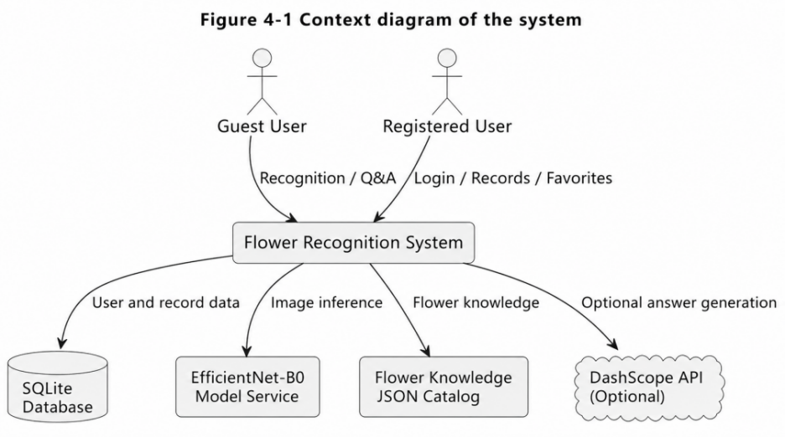
Figure 4-1: Context diagram of the system.

4.2.1 Users
The users of this system are mainly divided into two categories : tourist users and registered users. Tourist users do not need to log in to enter the system, can use the basic flower image recognition function, view the recognition results and flower science information, and can also use the lightweight question and answer function in the current page session. The tourist mode reduces the threshold of system use, so that users can quickly experience the core functions of the system.
Registered users are users who complete account registration and login in the system. Compared with tourist users, registered users can not only use flower identification, result display, knowledge browsing and Q & A functions, but also save identification history, manage collection flowers and save Q & A sessions. The system distinguishes the data of different users through user identity authentication, so that each user can only access their own historical records, favorite lists and Q & A sessions.
From the perspective of usage scenarios, tourist users are more suitable for temporary and fast flower recognition needs, while registered users are more suitable for long-term use of the system, accumulation of recognition records and management of scenes of flowers of personal interest. Therefore, the system retains the visitor mode and the login mode at the same time, so that the system has good openness and can support personalized data management.

4.2.2 External Systems
The system consists of a number of mutually cooperative parts. The front end is implemented by Vue and Vite, which is mainly responsible for user interface display, image upload, recognition result display, flower knowledge display, historical collection interaction and question and answer interface display. The main operation of the user is completed through the front-end page, and the front-end communicates with the back-end service through the HTTP request.
The back-end is implemented by FastAPI, which is the data processing and interface service center of the system. The back-end is responsible for receiving front-end requests, completing user authentication, image recognition request forwarding, flower information query, historical record preservation, collection management and question and answer session management. The back-end connects the database, model service and flower knowledge base at the same time, which is the core coordination layer between the various parts of the system.
The model service is implemented based on PyTorch, and the final deployment model is EfficientNet-B0. After uploading flower pictures on the front-end, the back end will call the model service for image preprocessing and model inference, and the model outputs prediction categories, Top-3 results and confidence. This part is the core of the system to realize the automatic identification of flowers.
The database uses SQLite and data management is performed through SQLAlchemy. The database mainly saves user information, flower species information, identification history, collection records, Q & A sessions and Q & A messages. For logged-in users, the system relies on the database to achieve persistent preservation of personalized data.
The flower knowledge base uses local JSON data and writes or synchronizes to the flower species table in the database when the system is initialized. The knowledge base provides basic data for recognition result display and question answering context construction. In addition, the system also reserves the DashScope / Bailian API as an optional external Q & A generation interface, which can generate more natural Q & A responses when the interface is available.

4.2.3 System Feature
According to the system requirements and actual implementation, the system mainly includes four functions : user authentication, flower recognition and result display, flower knowledge and user record management, and lightweight question answering. Figure 4-2 shows the main use case relationships of the system, in which visitor users can use basic identification, knowledge browsing and temporary Q & A functions, and registered users can further manage identification history, collection records and Q & A sessions.
(1) User Authentication
User authentication function mainly includes user registration, user login and current user identification. When users register, they need to enter the user name, mailbox and password. The back-end verifies the user input and saves the password to the database after hashing. When the user logs in, the system queries the user record according to the user name, and verifies whether the input password matches the password hash stored in the database.
After successful login, the back-end will generate an access token and return it to the front-end. The front-end will carry the Token in the request header when the subsequent request collection, history, and Q & A sessions require an authentication interface. The back-end obtains the current user identity by parsing Token, so as to ensure that different users can only access their own personal data. The overall process of this function is shown in Figure 4-3.
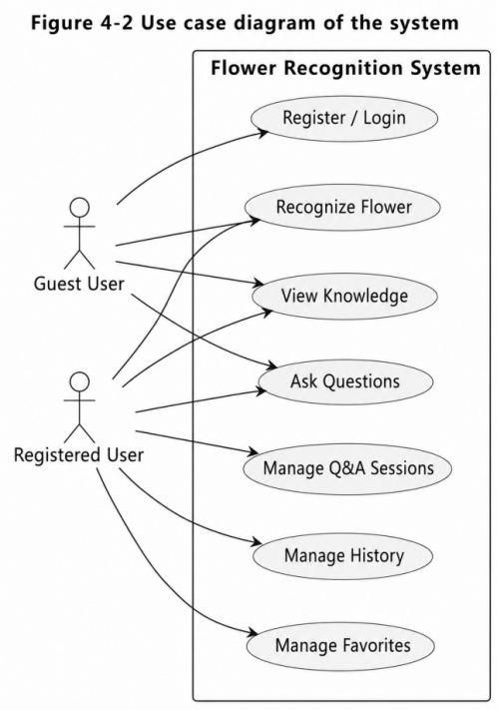
Figure 4-2: Use case diagram of the system
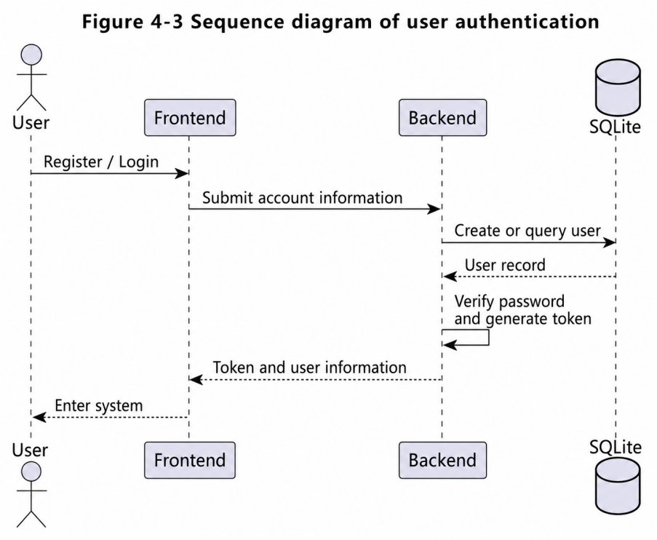
Figure 4-3: Sequence diagram of User Authentication
(2) Flower Recognition and Result Display
Flower recognition and result display are the core functions of the system. After the user selects and uploads the flower pictures in the front-end, the front-end sends the picture files to the back-end identification interface. The back-end reads the image data and calls the model service to complete the image preprocessing and EfficientNet-B0 model inference. After Softmax calculation, the model returns the prediction category, Top-3 recognition result and corresponding confidence.
After the back-end obtains the model output, it will query the flower knowledge data according to the prediction category, and return the recognition result and the flower science information to the front-end. The front page shows the predicted flower name, category number, confidence progress bar and Top-3 result list, so that users can intuitively understand the model judgment results. For logged-in users, the system will also save the identification results to the identification history. The identification process is shown in Figure 4-4.
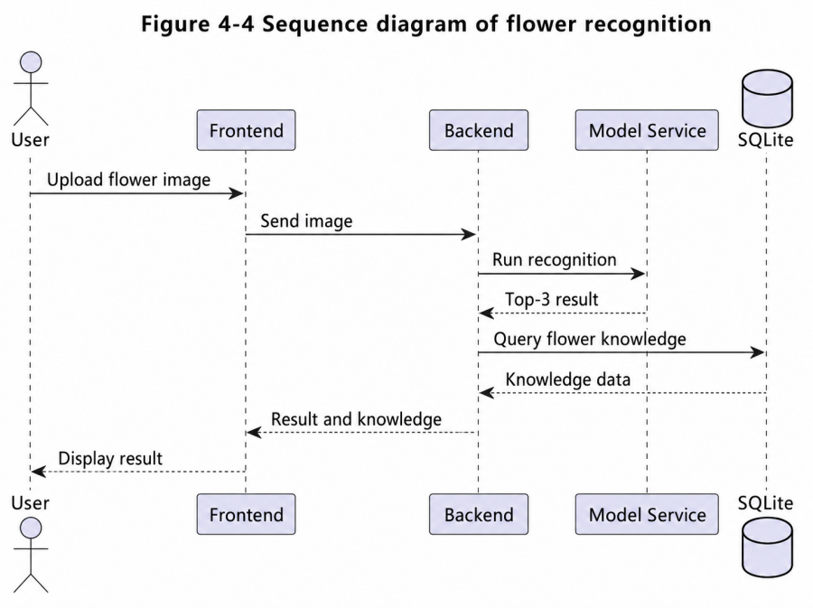
Figure 4-4: Sequence diagram of flower recognition
(3) Flower Knowledge, History and Favorite Management
The flower knowledge display function is used to supplement the recognition results, so that the system can not only give the classification results, but also provide the corresponding flower science information. The system queries the flower knowledge data according to the identified category number, and displays the flower name, English name, introduction, flower language, flowering period, maintenance suggestions and labels. Users can also actively search for relevant flower information through the flower retrieval function.
The identification history function is for logged-in users. When the login user completes the image recognition, the system will automatically save the recognition record, including the prediction category, the prediction name, the confidence level, the Top-3 result and the recognition time. Users can view recent identification results in the history area or delete unwanted records.
The collection management function is also for logged-in users. Users can add flowers of interest to the collection list, which can be quickly viewed in the collection area. The system supports adding collections, viewing collections, and canceling collections. Through historical records and collection management, the system can be extended from a one-time identification tool to a flower science platform with personal data management capabilities.
(4) Lightweight Question Answering
The lightweight question answering function is used to support users to ask further questions around flower knowledge. Users can enter questions in the question and answer interface, and the front end sends questions, current flower number and session information to the back end. The back-end first constructs context content based on current flower information, including flower name, introduction, growth environment, flowering period, flower language and maintenance suggestions, and then generates question and answer tips based on recent conversation content.
When the external DashScope / Bailian API is available, the system calls the external large model interface to generate an answer ; when the external interface is unavailable or the call fails, the system will use the local templated answer as the fallback scheme to ensure that the question answering function can still return the results normally. For logged-in users, the system saves Q & A sessions and message records ; for tourist users, the system only retains short-term context in the current front-end session. The functional process is shown in Figure 4-5.
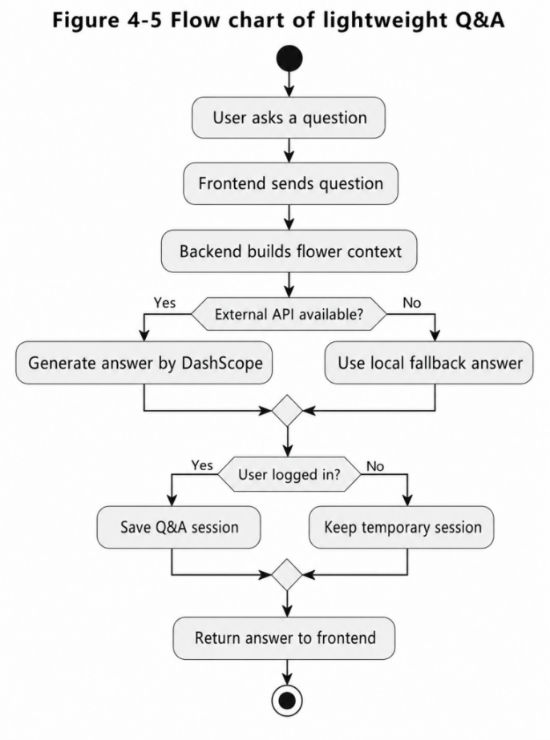
Figure 4-5: Flow chart of lightweight Q&A

4.3 System Interface
This section mainly introduces the main interface design of flower recognition and popular science system. The system interface revolves around ‘ picture recognition, result display, knowledge browsing, record management and question and answer interaction ’. The overall layout is kept as simple and intuitive as possible, so that users can quickly upload pictures, view recognition results and obtain flower knowledge. Since the system supports both tourist users and registered users, the interface also distinguishes the design of login status, historical records, collection management and Q & A sessions.

4.3.1 Interface Generalization
The main interface of the system adopts the layout method of combining side navigation with content area. The side navigation bar provides entrances such as identification page, question and answer page, flower science library and platform record, and the content area displays the corresponding function page according to the user’s choice. Login users can save identification history, collection records and Q & A sessions ; visitor users can use basic identification and temporary question and answer functions, but the relevant data will not be stored in the database.
The whole system interface emphasizes clear function and intuitive operation. The recognition page highlights image uploading and recognition result display ; popular science library page highlights flower retrieval and knowledge browsing ; the platform record page focuses on displaying historical records and collections ; the Q & A page revolves around flower knowledge Q & A. Through this partitioning method, users can quickly find the required functions.

Figure 4-6 Overall interface structure of the flower recognition system

Figure 4-7 Registration and login interface

4.3.2 Registration and Login Interface
The registration and login interface is the entrance for users to enter the system. The interface provides two modes of login and registration, and the user can select the corresponding operation by switching the button. When logging in, the user needs to enter the user name and password ; when registering, the user needs to enter the user name, mailbox and password. The system also provides a visitor entrance, so that users can also experience basic identification and question answering functions without registration.
The design of the interface is relatively simple, which is mainly composed of system name, login registration form, error prompt and visitor entry button. For registered users, the system will enter the main function interface after successful login ; for new users, after successful registration, they can also directly enter the system and use the functions corresponding to the logged-in users.

4.3.3 Flower Recognition and Result Interface
Flower recognition page is the core function page of the system. Users can select local flower pictures on this page, or upload pictures by drag and drop. After the completion of the image selection, the system will display the image preview and file information in the page. After the user clicks the recognition button, the front end sends the image to the back-end interface, and the back-end calls the EfficientNet-B0 model to complete the recognition.
After the recognition is completed, the page will display the predicted flower name, category number, recognition confidence and Top-3 prediction results. The confidence is presented in the form of numerical values and progress bars, and the Top-3 region shows the three flower categories and their probabilities that the model considers most likely. Users can copy and collect according to the recognition results, or directly enter the question and answer page to continue asking questions about the current flowers.

Figure 4-8 Flower Recognition and Result Interface

4.3.4 Flower Knowledge Base Interface

Figure 4-9 Flower Knowledge Base Interface
The flower science library page is used to display the flower knowledge data built into the system. Users can search flowers through keywords, such as entering English name, Chinese name or related keywords, and the system will retrieve the matching results from the flower knowledge base. The search results are presented in the form of cards, each containing a flower picture, a flower name, an English name, a category number, an introduction, and label information.
The page also supports picture preview and question answering based on the current flower. Users can click on the flower picture to view a larger preview picture, click on the question and answer button to jump to the question and answer page, and use the current flower as the question and answer context. Through the popular science knowledge base page, the system can not only display the knowledge corresponding to the recognition results, but also support users to actively browse and query the information of different flowers.

4.3.5 History and Favorite Interface
The platform record page mainly includes two parts : identification history and collection record, and provides personal data management function for login users. After the user completes the flower recognition, the system will save the recognition results, including the recognition name, confidence and recognition time, and display them in the historical record area. Users can view recent recognition results or delete unwanted historical records.
The collection area is used to save flowers that users are interested in. After the user clicks on the collection on the recognition result page, the system will add the corresponding flowers to the collection list. The platform record page displays the historical records and collections, which is convenient for users to review the past recognition results and quickly access the flower information they pay attention to. In the visitor mode, the area will prompt that the data will not be saved.

Figure 4-10 History and favorite interface

4.3.6 Question Answering Interface

(1)

(2)
Figure 4-11 Question answering interface
The question and answer page is used to support users to ask further questions around flower knowledge. Users can enter the question and answer page from the recognition result page, or select a flower from the flower science library to initiate a question and answer. If the system has obtained the current flower information, the question and answer page will display the name, English name, introduction, flower language, flowering period, growth environment and label of the flower as the question and answer context.
The main body of the Q & A page consists of a conversation area and a question input area. After the user enters the question, the system will generate an answer based on the current flower data and the recent dialogue content, and display the user question and the system reply in the session area. The Q & A session of the login user can be saved and viewed in the sidebar, while the visitor user only retains the temporary conversation content of the current page.

4.4 Chapter Summary
This chapter explains the design and development of flower recognition and science popularization system. Firstly, the system objectives are analyzed from two aspects of functional requirements and non-functional requirements. Then, the system users, external systems and main functions are introduced, and the system context, use case relationship and key business processes are explained through relevant diagrams. Finally, combined with the current front-end implementation, this chapter introduces the registration login interface, flower recognition and result interface, flower science library interface, historical collection interface and question and answer interface.
Through the analysis of this chapter, it can be seen that the system takes flower image recognition as the core, and expands the functions of popular science browsing, historical records, collection management and lightweight question and answer. The front end organizes the recognition, popular science, recording and question answering functions in a unified platform through clear page partition and navigation design, providing users with a more complete flower recognition and popular science service.

CHAPTER 5: CONCLUSION AND FUTURE WORK

5.1 Conclusion
This paper focuses on the theme of “ design and implementation of flower intelligent recognition and popular science system based on Web, ” and completes the design and implementation of flower image recognition model training, Web system development, flower popular science information display and lightweight question answering function. The system is oriented to the needs of ordinary users to identify flowers and acquire relevant knowledge in campus, parks, horticulture and other scenes. It provides functions such as image upload recognition, Top-3 result display, flower knowledge browsing, historical records, collection management and popular science question answering.
In terms of flower recognition methods, this paper uses Oxford 102 Flowers data set as the experimental data source, and compares three classical convolutional neural networks, MobileNetV2, ResNet18 and EfficientNet-B0, based on the transfer learning method. Aiming at the problems of limited training samples, large number of categories and obvious fine-grained features of flower images in Flowers102, this paper uses a two-stage fine-tuning strategy for training : the first stage freezes the feature extraction layer and only trains the classification head ; in the second stage, all network layers are thawed, and the overall fine-tuning is performed using a smaller learning rate.
The experimental results show that EfficientNet-B0 performs best among the three models. The ablation study also shows that random data augmentation improves test generalization, and full fine-tuning is more effective than training only the classification head. The accuracy of the verification set reaches 89.80%, and the accuracy of the test set reaches 87.45%. Therefore, EfficientNet-B0 is finally selected as the system deployment model. In terms of system implementation, this paper adopts the front-end and back-end separation architecture. The analysis of confusion matrix and confusable category pairs further shows that the remaining errors of the model are mainly concentrated between flower categories with similar appearance, indicating that the overall recognition ability of the model is good, but there is still room for further improvement in fine-grained flower discrimination.
The front-end implements the user interface based on Vue.js and Vite, and the back-end provides interface services based on FastAPI. The model inference part is implemented by PyTorch, and the database uses SQLite to store user information, identification history, collection records and question and answer sessions. Through the collaboration between front-end, back-end, model service and database, the system realizes the complete process from flower picture upload, model recognition, result return to popular science information display. The system has also been deployed on a cloud server, which verifies the feasibility of applying the flower recognition and popular science functions in an online Web environment.
In addition, this paper also designs a lightweight popular science question answering module based on structured JSON flower knowledge base. The system can retrieve relevant knowledge according to the identified flower categories, and generate answers based on user questions.

5.2 Future Work
Although this paper has completed the training of the flower recognition model, the development of the Web system and the implementation of lightweight popular science question answering, there is still room for further improvement.
(1) Improve the Accuracy of Flower Recognition
In this paper, EfficientNet-B0 is finally used as the flower recognition model, and good experimental results are obtained. However, from the analysis of confusion matrix and easily confused category pairs, it can be seen that the model is still prone to misjudgment between flower categories with similar appearance. For example, petunia is often misclassified as hibiscus, azalea, balloon flower, tree mallow and mexican petunia, indicating that the model is still insufficient in distinguishing categories with similar corolla morphology, petal color and overall contour.
In the future, more training samples can be added for these easily confused categories, and more targeted data enhancement strategies can be designed, such as adding images under different illumination, shooting angle, openness and background conditions.
(2) Expand the Flower Dataset
In this paper, the Oxford 102 Flowers dataset is used for model training and testing, but the category range and the number of training samples of the dataset are still limited. In practical applications, users may upload pictures from different regions, devices, and shooting environments, and may also include flower categories outside the data set. Therefore, in the future, we can continue to collect more flower images, expand recognizable categories, and supplement samples under different illumination, background, angle and growth stages to improve the adaptability of the model in real scenes.
(3) Improve the Flower Knowledge Base
The current system has built a structured flower knowledge base, but the content of some flower entries is still incomplete. Subsequently, the Chinese name, English name, classification information, morphological characteristics, distribution area, flowering period, ecological habits, maintenance methods and cultural meanings of 102 kinds of flowers can be further supplemented, and sample pictures and label information can be added, so that the system can provide more complete, intuitive and accurate popular science services.
(4) Introduce Vector Database-based RAG
This paper implements a lightweight retrieval-augmented question answering function based on local JSON data. Although this method is simple and suitable for the current system scale, its semantic retrieval ability is still limited. In future work, a vector database-based RAG mechanism can be introduced to improve semantic retrieval and answer generation. Gao et al. summarized the development of RAG for large language models [32], which provides a general reference for improving knowledge-intensive question answering. Huang and Huang reviewed retrieval-augmented text generation methods [33], showing that retrieval can enhance the quality of generated answers. Fan et al. further discussed the combination of RAG and large language models [34], while Zhao et al. analyzed retrieval-augmented generation in AI-generated content systems [35]. These studies provide useful references for building a more complete flower knowledge question answering module.
(5) Optimize System Deployment and User Experience
The current system has been integrated and deployed on a cloud server for online access. In the future, the deployment process can be further optimized through containerization, model compression or inference acceleration. At the same time, the front-end interaction can also be improved, such as adding clearer progress prompts, error messages, mobile adaptation and more refined knowledge card design, so as to improve system stability and user experience.

Reference
- Krizhevsky A, Sutskever I, Hinton G E. ImageNet Classification with Deep Convolutional Neural Networks[C]// Advances in Neural Information Processing Systems. 2012, 25.
- Nilsback M E, Zisserman A. Automated Flower Classification over a Large Number of Classes[C]// 2008 Sixth Indian Conference on Computer Vision, Graphics & Image Processing. IEEE, 2008:722-729.
- He K, Zhang X, Ren S, Sun J. Deep Residual Learning for Image Recognition[C]// Proceedings of the IEEE Conference on Computer Vision and Pattern Recognition. 2016:770-778.
- Sandler M, Howard A, Zhu M, Zhmoginov A, Chen L C. MobileNetV2: Inverted Residuals and Linear Bottlenecks[C]// Proceedings of the IEEE Conference on Computer Vision and Pattern Recognition. 2018:4510-4520.
- Tan M, Le Q V. EfficientNet: Rethinking Model Scaling for Convolutional Neural Networks[C]// Proceedings of the 36th International Conference on Machine Learning. PMLR, 2019:6105-6114.
- Lewis P, Perez E, Piktus A, Petroni F, Karpukhin V, Goyal N, Küttler H, Lewis M, Yih W, Rocktäschel T, Riedel S, Kiela D. Retrieval-Augmented Generation for Knowledge-Intensive NLP Tasks[C]// Advances in Neural Information Processing Systems. 2020, 33:9459-9474.
- Wäldchen J, Mäder P. Plant Species Identification Using Computer Vision Techniques: A Systematic Literature Review[J]. Archives of Computational Methods in Engineering, 2018, 25(2):507-543.
- Yao J, Tran S N, Garg S, Sawyer S. Deep Learning for Plant Identification and Disease Classification from Leaf Images: Multi-Prediction Approaches[J]. ACM Computing Surveys, 2024, 56(6):1-37.
- Barhate D, Pathak S, Singh B K, Jain A, Dubey A K. A Systematic Review of Machine Learning and Deep Learning Approaches in Plant Species Detection[J]. Smart Agricultural Technology, 2024, 9:100605.
- Goëau H, Bonnet P, Joly A. Overview of PlantCLEF 2023: Image-Based Plant Identification at Global Scale[C]// CLEF 2023 Working Notes. CEUR Workshop Proceedings, 2023.
- Goëau H, Espitalier V, Bonnet P, Joly A. Overview of PlantCLEF 2024: Multi-Species Plant Identification in Vegetation Plot Images[R/OL]. HAL, 2024.
- Weiss K, Khoshgoftaar T M, Wang D. A Survey of Transfer Learning[J]. Journal of Big Data, 2016, 3(1):9.
- Deng J, Dong W, Socher R, Li L J, Li K, Fei-Fei L. ImageNet: A Large-Scale Hierarchical Image Database[C]// IEEE Conference on Computer Vision and Pattern Recognition. IEEE, 2009:248-255.
- Karpukhin V, Oguz B, Min S, Lewis P, Wu L, Edunov S, Chen D, Yih W T. Dense Passage Retrieval for Open-Domain Question Answering[C]// Proceedings of the 2020 Conference on Empirical Methods in Natural Language Processing. Association for Computational Linguistics, 2020:6769-6781.
- Guu K, Lee K, Tung Z, Pasupat P, Chang M W. REALM: Retrieval-Augmented Language Model Pre-Training[C]// Proceedings of the 37th International Conference on Machine Learning. PMLR, 2020:3929-3938.
- Lee C P, Lim K M, Song Y X, Alqahtani A. Plant-CNN-ViT: Plant Classification with Ensemble of Convolutional Neural Networks and Vision Transformer[J]. Plants, 2023, 12(14): 2642.
- Mulugeta A K, Sharma D P, Tegegne A W, et al. Deep Learning for Medicinal Plant Species Classification and Recognition: A Systematic Review[J]. Frontiers in Plant Science, 2024, 14: 1286088.
- Dey B, Ferdous J, Ahmed R, Hossain J. Assessing Deep Convolutional Neural Network Models and Their Comparative Performance for Automated Medicinal Plant Identification from Leaf Images[J]. Heliyon, 2024, 10(1): e23655.
- Figueroa-Flores C, San-Martin P. Deep Learning for Chilean Native Flora Classification: A Comparative Analysis[J]. Frontiers in Plant Science, 2023, 14: 1211490.
- Guan H, Chen F, Zhang G, Li K, Wang P, Zhu Z. A Lightweight Model for Efficient Identification of Plant Diseases and Pests Based on Deep Learning[J]. Frontiers in Plant Science, 2023, 14: 1227011.
- Chen Y, Huang Y, Zhang Z, et al. Plant Image Recognition with Deep Learning: A Review[J]. Computers and Electronics in Agriculture, 2023, 212: 108072.
- Picek L, Šulc M, Patel Y, Matas J. Plant Recognition by AI: Deep Neural Nets, Transformers, and kNN in Deep Embeddings[J]. Frontiers in Plant Science, 2022, 13: 787527.
- Dosovitskiy A, Beyer L, Kolesnikov A, et al. An Image is Worth 16×16 Words: Transformers for Image Recognition at Scale[C]// International Conference on Learning Representations. 2021.
- Liu Z, Lin Y, Cao Y, et al. Swin Transformer: Hierarchical Vision Transformer Using Shifted Windows[C]// Proceedings of the IEEE/CVF International Conference on Computer Vision. 2021: 10012-10022.
- Liu Z, Mao H, Wu C Y, et al. A ConvNet for the 2020s[C]// Proceedings of the IEEE/CVF Conference on Computer Vision and Pattern Recognition. 2022: 11976-11986.
- He K, Chen X, Xie S, et al. Masked Autoencoders Are Scalable Vision Learners[C]// Proceedings of the IEEE/CVF Conference on Computer Vision and Pattern Recognition. 2022: 16000-16009.
- Radford A, Kim J W, Hallacy C, et al. Learning Transferable Visual Models From Natural Language Supervision[C]// International Conference on Machine Learning. PMLR, 2021: 8748-8763.
- Paszke A, Gross S, Massa F, Lerer A, Bradbury J, Chanan G, Killeen T, Lin Z, Gimelshein N, Antiga L, Desmaison A, Kopf A, Yang E, DeVito Z, Raison M, Tejani A, Chilamkurthy S, Steiner B, Fang L, Bai J, Chintala S. PyTorch: An Imperative Style, High-Performance Deep Learning Library[C]// Advances in Neural Information Processing Systems. 2019, 32:8024-8035.
- Yosinski J, Clune J, Bengio Y, Lipson H. How Transferable Are Features in Deep Neural Networks?[C]// Advances in Neural Information Processing Systems. 2014, 27.
- Goodfellow I, Bengio Y, Courville A. Deep Learning[M]. Cambridge: MIT Press, 2016.
- Kingma D P, Ba J. Adam: A Method for Stochastic Optimization[C]// International Conference on Learning Representations. 2015.
- Gao Y, Xiong Y, Gao X, Jia K, Pan J, Bi Y, Dai Y, Sun J, Wang M, Wang H. Retrieval-Augmented Generation for Large Language Models: A Survey[J/OL]. arXiv preprint arXiv:2312.10997, 2024.
- Huang Y, Huang J. A Survey on Retrieval-Augmented Text Generation for Large Language Models[J/OL]. arXiv preprint arXiv:2404.10981, 2024.
- Fan W, Ding Y, Ning L, Wang S, Li H, Yin D, Chua T S, Li Q. A Survey on RAG Meeting LLMs: Towards Retrieval-Augmented Large Language Models[C]// Proceedings of the 30th ACM SIGKDD Conference on Knowledge Discovery and Data Mining. ACM, 2024:6491-6501.
- Zhao P, Zhang H, Yu Q, Wang Z, Geng Y, Fu F, Yang L, Zhang W, Jiang J, Cui B. Retrieval-Augmented Generation for AI-Generated Content: A Survey[J/OL]. arXiv preprint arXiv:2402.19473, 2024.

Acknowledgment

